
Notional Interoperability Architecture and Implementation Scheme
for the Shared Land Information Platform

Authors:
Michael Wilson
Dr Robert Starling
and
Dr Carl Reed

12th August 2003

Copyright © 2003, OGC, Inc., All Rights Reserved.
"OpenGIS® is a trademark or registered trademark of OGC, Inc. in the United States ^{and} in other countries".
All other products mentioned are registered trademarks or trademarks of their respective companies.

Executive Summary
The goals for the Shared Land Information Platform (SLIP) as stated by the Western Australian Government are achievable. Existing land information systems and services operating in different departments and agencies can be presented to the global Internet in a coherent manner. Land information services that are more readily available and accessible will be used more frequently, thereby increasing their value to all.
SLIP aligns with the WA Department of the Premier and Cabinet’s Office of e-Government’s, e-Government Interoperability Framework (e-GIF). e-GIF has been prepared in response to the Delivering Better Government Policy (www.premier.wa.gov.au/policies/public_sector_reform.pdf) and acknowledges the Commonwealth Government’s base policies and standards (as in NOIE 2003).
SLIP is to provide an extended framework for collaboration, building on existing inter-agency and private sector initiatives, to focus on information interchange, value-added services and delivery including to those users not necessarily expert in land information but who require such information to facilitate/improve their own cost-effective levels of service delivery.
SLIP, with implementation based on an interoperable framework, will enhance the value of the investment of existing land information systems and data without requiring a major re-engineered effort. The result can be achieved by implementing well-defined lightweight interfaces based on the specifications and standards promulgated in the OpenGIS community. The Open GIS Consortium and its partners are the authorities for these specifications.
SLIP will facilitate the more rapid and effective creation of customized products just in time to meet users’ requirements. It will reduce the current reliance on, and bottlenecks around, backroom technical experts who are frequently overburdened creating ad hoc products. A SLIP implementation based on an interoperable standards-based framework will put these specialist capabilities in the hands of any Internet user with a web browser.
SLIP will facilitate the ready creation of new and novel services as needs arise. The use of interoperability concepts, such as OpenGIS mechanisms, ensures that services can be connected to each other and combined in ways previously impossible, and at only marginal cost compared to any ground-up effort to build a new service from scratch.
SLIP requires that certain core services – such as a metadata catalogue, a registry of services and a gazetteer name service – be implemented and operated with high levels of reliability and availability. Such “spatial services” will also require near term access to security services (including authentication and authorization [single logon] services), auditing, metering, workflow and pricing, invoicing and settlement services. One or more of the agencies participating in the Western Australian Land Information System (WALIS) will need to elect or be designated as the custodian(s) of these core services. The Department of Land Information is establishing a land and property portal underpinned by extensive investment in infrastructure and spatial and e-business services; DLI may be an appropriate custodian of the core services.
SLIP will be consistent with other spatial data infrastructures (SDIs) being established elsewhere in Australia and around the world. SLIP will provide a two-way service conduit: services operated by elements of the Western Australian government will be accessible to wider (potentially global) audiences, and Western Australian audiences will gain access to services operating well outside the remit of the government of Western Australia. The international profile of WA land information services will be assured.
SLIP is designed for interoperability according to principles of open distributed system design not only applied in current web initiatives such as the OpenGIS community and OASIS (a not-for-profit, global consortium that drives the development, convergence and adoption of e-business standards) but also emerging technologies such as the global grid forum (a community-initiated forum working on distributed computing, or "grid" technologies). The SLIP concept is thus positioned for future as well as present interoperability.
SLIP is designed to exploit the flexibility of the Internet so as to be highly decentralized, secure and fault tolerant, with high resilience and good failover-recovery in case of the loss of any node.
SLIP users will be able to interoperate not only amongst WALIS agencies but also with the broader community of land information users, including local government, commercial and community service providers, government bodies in other states and the Commonwealth government.

Recommendations
The following are the key recommendations. These recommendations are based on the OGC team’s understanding of the requirements of DLI as well as experience gained from similar projects.
- A commitment be made for SLIP to be created within an open, distributed, standards based computing architecture with a phased implementation.
The phased implementation plan would include:
- Putting in place ASAP a systematic approach to appropriate metadata capture and storage in a compliant metadata catalogue.
- The SLIP services registry be designed and implemented ASAP.
- WALIS collaborators committing to implementing SLIP as soon as a host for the SLIP registry is identified and make the portal available to WALIS participants.
- Individual WALIS agencies, or suitable commercial or community providers, implementing other SLIP core functions such as a gazetteer name service.
- A programme to schedule the incremental expansion of SLIP services, including services provided by WALIS custodians as well as appropriate services operating interstate or overseas in other SDIs.
- A programme for incremental development of user audit and management services to phase SLIP through provision of unregistered free-to-air services (with accounting for utilization), user registration, user registration plus access control, to user cost accounting, and that exchanges be undertaken with partners operating user management services, such as GeoScience Australia
- WALIS agencies scheduling implementation of the necessary OpenGIS interface elements over their current land information services to make them interoperable.
- SLIP being opened to broader usage as a platform for commercial, community and civil groups.

Table of Contents
Executive Summary I
Recommendations II
Table of Contents i
Table of Figures iii
Tables iii
1 Introduction 1-1
1.1 Background to the consultancy 1-1
1.2 The Shared Land Information Platform 1-1
1.3 Review of phase 1 findings as related to SLIP 1-2
1.4 Desired Objectives for an operational SLIP 1-3
1.5 Background considerations. 1-3
1.6 Approach 1-4
1.7 Recommendations arising from Background 1-5
2 Notional Architecture – Aligning WA globally and nationally 2-5
2.1 Foundation Concepts 2-5
2.2 Context: Spatial Data Infrastructures 2-5
2.3 The SDI Services Model 2-6
2.4 The SDI Component Model 2-8
2.5 SDI Standards, Protocols and Specifications 2-8
2.5.1 Authentication and Access Control 2-9
2.5.2 Registry Services 2-11
2.6 Positioning SLIP for the global spatial data infrastructure 2-14
2.6.1 Examples of Services Available to SLIP through the GSDI 2-15
2.7 Positioning SLIP for the Australian spatial data infrastructure ASDI - hooks 2-15
2.8 WA Spatial Infrastructure 2-16
2.9 Recommendations Arising from Notional Architecture 2-16
2.10 WA Infrastructure trends 2-17
3 Notional architecture - E-services and Interoperability as per OGC Reference Model 3-18
3.1 The Enterprise Viewpoint 3-18
3.1.1 Essential Enterprise Usage Scenarios 3-19
3.2 The Information Viewpoint 3-21
3.3 The Computational Viewpoint 3-22
3.3.1 The SLIP Service Design Concept 3-23
3.3.2 Application Services 3-29
3.3.3 Portrayal Services 3-30
3.3.4 Processing Services 3-31
3.3.5 Catalogue and Registry Services 3-31
3.3.6 Audit and Management Services 3-32
3.3.7 Data Repositories 3-32
3.3.8 Data Services 3-32
3.3.9 Portrayal Services 3-33
3.3.10 Processing Services 3-33
3.4 Engineering Viewpoint 3-39
3.4.1 Application Integration Framework 3-39
3.4.2 Distribution of SLIP Components 3-39
3.4.3 User interactions mediated through SLIP 3-43
3.4.4 Sample Use Case Summaries 3-43
3.5 Technology Viewpoint 3-47
4 Institutional Issues Arising from the Recommendations 4-51
4.1 Outline implementation sequence for SLIP 4-51
4.2 New service opportunities 4-55
4.3 Governance Issues, Policy, Dependencies and High Level Requirements: functional elements required for the SLIP 4-55
4.3.1 Dependencies and service exchange agreements 4-55
4.3.2 Managing knowledge of services and their characteristics – The SLIP Registry of Services 4-55
4.3.3 Managing knowledge of custodians and service providers – an Institutional Registry 4-55
4.3.4 Managing knowledge of users and their characteristics – a Customer Registry 4-56
4.3.5 Managing service level agreements, including for metadata services – an Interaction Registry, 4-56
4.3.6 Managing knowledge of data elements and their characteristics 4-57
4.3.7 Spatially related data services 4-57
4.3.8 e-authentication services 4-57
4.3.9 e-business services 4-58
4.3.10 e-government services 4-59
4.3.11 Conclusions in relation to the institutional issues and context for SLIP. 4-61
4.4 Conclusion: Implementing the SLIP strategic framework. 4-61
5 Bibliography 5-63
6 Appendices 6-66
6.1 Appendix 1: ISO/IEC 10746 overview 6-66
6.1.1 Conformance 6-66
6.1.2 Viewpoint correspondences 6-66
6.1.3 Reference points 6-67
6.1.4 Normative references 6-67
6.1.5 Terms and definitions 6-67
6.2 Appendix 2:A discussion of Components-Based Modeling 6-69
6.3 Appendix 3: Examples of GSDI-enabled services - the CGDI 6-71
6.4 Appendix 4: Services Registry Sample Content 6-79
6.5 Appendix 5: Specifications and Standards 6-81
6.5.1 Notional Components and their Related Specifications 6-81
6.5.2 Status of Pertinent Specifications 6-82

Table of Figures
Figure 1.1: SLIP Provides an Integrating Interface to WALIS systems 1-2
Figure 2.1: Relative and Hierarchical Roles of SDI Nodes 2-6
Figure 2.2: SLIP’s Publish-Find-Bind Model 2-7
Figure 2.3: OpenGIS Standards and their Distinct Roles 2-8
Figure 2.4: Interfaces for the ‘WRS Provider’ conformance class 2-12
Figure 2.5: Federated Registries 2-13
Figure 2.6: Departmental Interoperability Interfaces from WALIS services to the GSDI 2-14
Figure 3.1: Envisaged SLIP Major Enterprise Segments 3-18
Figure 3.2: Representative SLIP process management and utilization use cases 3-20
Figure 3.3: Computational Elements of SLIP 3-22
Figure 3.4: SLIP Services Design Concept Summary 3-25
Figure 3.5: Major SLIP Packages 3-27
Figure 3.6: Representative SLIP Process Components 3-35
Figure 3.7: Major SLIP Packages, Components and Interfaces 3-37
Figure 3.8: User Interface Package 3-40
Figure 3.9: Harvesting Data Sources Package 3-41
Figure 3.10: Publishing Package 3-42
Figure 3.11: Discovery Package 3-42
Figure 3.12: Viewing Package 3-43
Figure 3.13: SLIP Portal Technology Viewpoint 3-48
Figure 4.1: Notional SLIP Component Implementation Sequence and Capability Dependencies 4-53
Figure 4.2: Message Broker Architecture 4-58
Figure 4.3: XML Web Services Technical Model in e-government 4-59
Figure 4.4: E-Government Interoperability Model 4-60

Tables
Table 4-1: Incremental SLIP Implementation Outline 4-51

Introduction

Background to the consultancy
The Western Australian Department of Land Information (DLI) (formerly the Department of Land Administration, DOLA) is responsible for the State's cadastre and topographic mapping, tenure, valuations, remote sensing and aerial photography.
The Open GIS Consortium (OGC) is an international industry consortium of more than 250 companies, government agencies, and universities participating in a consensus process to develop publicly available geo-processing specifications. These and other, related specifications are widely adopted under the aegis of the development of national spatial data infrastructure initiatives (NSDIs) and their global counterpart, the GSDI.
DPI (at that time DOLA) commissioned the OGC to recommend means for aligning technology strategies to new business strategies emerging as results of current changes to DLI’s statutory mandate. In particular DLI seeks to align the services provided via its “Landgate” land information portal to the broader requirements of a Shared land Information Platform (SLIP) servicing ‘joined-up government’ at the State level, the Australian spatial data infrastructure at a national level, and the and Global Spatial Data Infrastructure (GSDI) internationally.
On the basis of these recommendations DLI commissioned a second phase of consultation to develop a notional architecture for SLIP based on open standards and specifications within a GSDI framework.

The Shared Land Information Platform
SLIP is to provide a new level of services to the WA Real Property and Land special interest groups as well as the public at large. SLIP is to serve professional and casual users with equal facility using the ubiquitous communications infrastructure of the Internet and a universal user access mechanism, a standard web browser.
SLIP is based on the common sense principal that “users have questions and want answers” – the answers must be affordable, correct and delivered quickly.
SLIP represents the Department of Land Information and its sister agencies’ commitment to “joined up government” by releasing a platform for asset realisation, education, innovation, market development, public participation and research and development.
SLIP is positioned as a “superstructure” to hide the complexities of departmental operational information creation and management systems from casual users, whether working within government or outside.
SLIP is an automated information production line that will take inquiries from a user, use its directories to find the information required, supervises reprocessing the raw information and manages delivery of the answer. SLIP will also monitor production costs for metering and, as appropriate, billing.
SLIP’s success depends on the use of international standards, supported by governments, industry and technology vendors, to enable an open dialogue between data and processing assets for the delivery of answers, and to receive customer feedback.
SLIP respects the security of the data and process suppliers with associated custodial responsibilities.
The Shared Land Information Platform (SLIP) is an open, interoperable and distributed processing environment that crosses organizational boundaries. It will employ OpenGIS specifications and other specified service standard interfaces to ensure interoperation with and service delivery to a variety of components deployed within multiple communities. SLIP will leverage existing OGC Web Services interface specifications to enable:
-   the publication of the availability of land information services and data;
-   the registration and categorization of published service and data providers; and
-   the discovery and use of needed land information services and data
SLIP will employ and enable transaction-based service request delivery, especially for creation of just-in-time products in response to external requests. It will embody a components-based architecture based on OpenGIS encoding protocols and interface specifications.

tc.

‘Land information’ is a very broad term that impinges on many large-scale systems in a range of sectors: utilities, primary production, extractive industries, water management, transportation, public health services, and more. Interacting with such systems involves a welter of political, economic, and legal issues that will not be raised here. Rather, SLIP is more about the creation and maintenance of a unified shared information operating environment to support operational, planning, and decision making activities associated with land information applications.
Departmental Data Management Systems
The Internet, the Backbone
SLIP
Departmental Interoperability Interfaces
Departmental Services
Seekers after Land Information Services
People
Remote
Systems
Agriculture
Mining
Planning
Environment
It is assumed that government departments utilizing the SLIP will have, to various degrees, existing operational services related to land information systems. For example DLI operates “Landgate”. These services implement Departmental guidelines and practices governing user authentication and authorization, data policy and security, utilization monitoring and billing. The requirements will be exposed to SLIP via a Departmental Interoperability Interface (DII) presenting unified standards-based interfaces for web-enabled services.
Figure 1.1: SLIP Provides an Integrating Interface to WALIS systems

Review of phase 1 findings as related to SLIP
It was recommended that:
- SLIP be based on a web services architecture as promulgated by ISO, OASIS, the W₃C and OGC;
- Technical interoperability be achieved through the implementation of OpenGIS Specifications;
- Legacy spatial data format interoperability be achieved through interface specifications such as the OpenGIS Web Feature Service Interface Specification and the encoding protocol for communication across the Internet be based on the Geographic Markup Language version 3.0 (GML) [23];
- A transactional model of ad hoc service request/responses be implemented;
- Data components and spatial processing services be defined through an information manufacturing model with supply/value chains, based on e-business standards

Desired Objectives for an operational SLIP
The architecture of the SLIP will:
- Enable managed, universal access to many kinds of geospatial and/or geospatially referenced information, anywhere, anytime;
- Enable applications to discover and access remote online information through a distributed infrastructure;
- Enable just-in-time integration of disparate geospatial information to provide seamless views;
- Enable applications to discover geoprocessing computational services though a distributed infrastructure;
- Provide geospatial update and exchange capabilities, enabling collaborative activities;
- Promote the sharing of geospatial semantics to facilitate integration of information;
- Enable wide-scale interoperability by adhering to common and open information standards and specifications;
- Facilitate the development of effective partnerships with state, national, regional and sector-specific Spatial Data Infrastructures (SDIs), and linkages with other national SDIs to form a Global Spatial Data Infrastructure (GSDI);
- Facilitate access to “private business applications, data and services” to promote the development of the spatial industry in WA;
- Leave open the possibilities for the seamless chaining of applications, data and services or combinations of these, as these capabilities are developed in the OpenGIS, grid computing and open commercial sectors
SLIP is to integrate a network of providers of information and services with consumers with applications that use the information and services provided by those organizations. It is to build upon federal, state, municipal, and industrial spatial data and initiatives, and is a collaborative information framework that integrates and functions with other spatial data infrastructures in existence and coming on-line around the world.
The infrastructure will provide clients with access to information and services, and will enable client applications to make use of geospatial information within other applications.

Background considerations.
SLIP’s primary role is to be one of application service integration, not merely data integration or data exchange.
Land information services are provided by existing and future applications operating on legacy systems. These legacy systems represent substantial investment in hardware, software licensing, staff training and expertise, and establish operational procedures.
Existing application and services are funded, operated and managed by many independent institutions and usually represent aspects of the core business – or, in some cases, statutory responsibilities - of these institutions. This will continue to be the case.
The applications are concerned with or supportive of, the development, maintenance and publication of geo-spatial and geospatially referenced data and their derived products.
Conserving the value of legacy systems (and their surrounding procedures, practices and expertise) is crucial while not imposing constraints on re-engineering options in the future.
Increasing legacy system value is highly desirable, to be achieved through implementation of new ancillary services or products, and/or increasing the exposure and rate of sale of current services or products, and/or by increasing the inherent quality (speed, accuracy, timeliness etc.) of the services or products and/or reducing the costs of core and ancillary data creation, management and supply.
The Office of e-Government, within the WA Department of the Premier and Cabinet, is preparing to release base policies and standards – the e-Government Interoperability Framework (August 2003). The draft document (June 2003), and related NOIE documents, have been reviewed to insure that the approach adopted for this study, and the report, align with the DPC statements of intent and direction.
The approach used in this analysis will emphasize interoperability, which is to be achieved through component-based services orientated architecture drawing on data-driven data modeling processes.
As will be seen in Section 2 The Notional Architecture many of the components required for SLIP are either mature or rapidly emerging from demonstration.

Approach
Drawing on the OGC Standards and Specifications: facilitating the alignment of DOLA’s business requirements and technology plans (2003), a number of Foundation Concepts are outlined to set a context for SLIP in relation to the international GDSI and then resolving to the notional architecture for WA and SLIP.
Notional architectures are presented from five non-overlapping, mutually consistent viewpoints, based on the methodology of the ISO Reference Model for Open Distributed Processing (RM-ODP) (ISO/IEC 10746) [1]. The RM-ODP provides the framework adopted by the OGC for specifying its reference architectures in the OGC Reference Model. [11][See Appendix 1 for a more complete delineation of the RM-ODP].
The five viewpoints are:
- Enterprise viewpoint focusing on the purpose, scope, and policies of a system, and providing the context and overall environment within which the system will be built, and therefore constraints, and obligations that must apply in all other viewpoints.
- Information viewpoint focusing on the information and associated processing of a system, using schemata to specify the way that information may be transformed.
- Computational viewpoint providing functional decomposition of a system into objects that interact at interfaces, which will provide natural lines along which a system may be partitioned for distribution.
- Engineering viewpoint focusing on the deployment aspects of a system, with explicit depiction of distribution rather than that merely implied in the computational viewpoint.
- Technology viewpoint focuses on specification of technologies to be implemented to realize the architecture as an operational system.

Recommendations arising from Background
The time is appropriate for a commitment amongst Western Australian land information custodians to create an open, distributed, standards-based computing platform for interoperable sharing of land information.
Such development can proceed incrementally, with demonstrated viability at each stage and the ability to test early and often.
Commitment to this course of action be taken and procedures established for identifying custodians’ commitments and responsibilities within an agreed framework for implementation of core capabilities.

Notional Architecture – Aligning WA globally and nationally
SLIP is to provide a “future proofing” for WA’s spatial and spatially referenced data and processing assets. The user base for WA data is certainly skewed towards local requirements however certain data are of national and international interest, in the same way those national and international data sets of interest to users in WA. Processing services, from coordinate reprojection to contaminant dispersion models, are being exposed to users on an as-needed basis through standard interfaces obviating the need for local copies of software. SLIP is to be designed and positioned to be a participatory node in the context of existing and emerging national and international data and processing service networks.

Foundation Concepts
The foundation of the SLIP notional architecture is that of the spatial data infrastructure linking providers and users of spatial and spatially related data and services in as flexible and ubiquitous a manner as transport and communication networks link service providers and users.
SLIP will provide Western Australia with capabilities consistent with those of the more than fifty nations that are developing national spatial data infrastructures (NSDIs) to improve their ability to find, access and more effectively use geospatial information and technology in their governmental and business activities. These national activities are supported by regional collaborative efforts in Asia and the Pacific, Europe, the Americas and Africa and an emerging Global Spatial Data Infrastructure (GSDI) effort.
SLIP is to expose data stores to the SDI via compliant service interfaces. The data themselves are available for examination, representation, processing or transfer in non-proprietary open standard formats. The services used to access the data stores are, in many cases, existing legacy systems which will have been adapted with appropriate wrappers or middleware to translate between their internal proprietary formats and the external open standard mechanisms required for interoperability within SDIs.
-
SLIP will enable Western Australian departmental data services, when equipped with appropriate departmental interoperability interfaces, to exchanges services and data with other SDI participants at State, Commonwealth and international levels. International connectivity options include the Asian-Pacific regional SDI, the United Nations SDI-based interoperability framework, service operated by the World Bank and OECD, and numerous non-governmental institutions such as the World Conservational Monitoring Centre and the World Resources Institute.

Context: Spatial Data Infrastructures
Institutional relationships within the GSDI tend to be hierarchical i.e. sub-national groups are represented by national bodies at regional and global fora. However, the implementation of the GSDI is not explicitly hierarchical. This will be equally true for SLIP.
Error: Reference source not found presents an idealized view of the possible interrelationships amongst SDI nodes operating at national, sub-national or international levels. Relationships may be horizontal amongst peers, vertical though international - national -sub-national links, or oblique e.g. directly from a sub-national node in one country to the national node of some other country.
SLIP will employ technical standards that are employed for SDIs, which are transparent to notions of hierarchy in the manner as the Internet World Wide Web (for example [8, 9, 2]). SDI standards foster interoperation amongst nodes as peers, whether as well-defined, permanent operation arrangements or as transitory ad hoc instances.
National and Regional Nodes
Sub-National Nodes in structured network
Ad hoc
service exchanges
Structured service exchanges
SLIP, like any national spatial data infrastructure, may include a node providing nation-wide access to sub-national (state, provincial, local, sectoral, community, commercial) nodes. However it is institutional requirements that determine the types of acceptable interoperability amongst nodes within a nation, sub-national nodes in different nations, or sub-national nodes of one country with national nodes of a different country. Departmental or sectoral nodes within a state or provincial SDI may interact with nodes in other states, provinces, regions, countries or communities according to local procedures, guidelines and requirements
Figure 2.2: Relative and Hierarchical Roles of SDI Nodes

The SDI Services Model
SLIP will enable the Western Australian geo-spatial information community to move comprehensively beyond the ‘map delivery’ services generally in place. Predefined and rigid product lines that rely on back-end GIS analysis will be complemented with web-enabled mapping services. Such services facilitate that migration of competence from GIS specialists to on-line users who are offered increased flexibility for ad hoc product creation and generation, especially when their requirements can only be met through combinations of information from multiple sources.
SDI services remove the necessity for information users to receive copies of data, and for them to have the GIS hardware, software and expertise to convert these data into their required information products. SDI services may optionally include data delivery as a service at the discretion of the data custodian.
SLIP-enabled geo-information services will employ the “Publish, Find and Bind” model of service interaction as used in OGC, OASIS, W3C, and grid computing communities. (See Figure 2.3: SLIP’s Publish-Find-Bind Model overleaf)
Service Custodians publish information about their offerings into service registries where potential clients can seek and identify services of interest. The information available in the registry defines not only the capabilities of the service such as the types of data used, but also information on usage policy such as needed authorizations, cost recovery practices and the like. Clients, once having found an appropriate service, and establishing their bona fides with the service custodian, may then connect (bind) their web client and receive the service.
Registry Service API
Requester
find
publish
bind
Provider
service offer
type definition
service instance
Separating the service processes (provided by WALIS collaborators) from the presentation and human-interaction interfaces (provided through web browsers and other clients) means that SLIP service custodians are strengthening the long-term protection of their geo-data infrastructure investments. For example, business decisions dictating new requirements to exploit emerging technical capabilities such as mobile computing and location based services will not require wholesale re-engineering of existing services. Instead, the publish-find-bind model enables system adaptation to be made as required to meet the capabilities of new clients, while the mission-critical backend business processes and services continue undisturbed.
Figure 2.3: SLIP’s Publish-Find-Bind Model
SLIP will implement each aspect of the “publish-find-bind” model. OpenGIS compliant catalogue and registry services support systematic standards-based publication of service, data and feature descriptors. Service policies (appropriate use, utilization monitoring and invoicing, etc.) are also made known at these interfaces. Each WALIS institution participating in SLIP will retain the choice whether to implement its own catalogues and repositories; conversely, there may be compelling cases for consolidating their needs with similar requirements in other organizations and so jointly providing a centralized catalogue service. The option is open for the centralized catalogue to be supported by a commercial provider. Similar considerations pertain to issues such as client authorization and management. OGC standards compliance ensures that each decision can be made on a case-by-case basis to best meet institutional requirements.
SLIP will support distributed search and discovery across multiple catalogues and registries. Again, standard protocols (SOAP, ISO 23950) exist already and are in wide implementation. These methods are already widely employed, including in the Australian Spatial Data Directory and the WALIS Interragator. Extending these capabilities through SLIP will require no fundamental shift, and by streamlining interoperation will open opportunities for WALIS agencies, that wish to do so, to exercise increased custodial authority over their metadata and catalogue entries.
Clients’ ability to bind to SLIP enabled services ultimately depends on internet-available protocols combined with various implementations of policies described in the registries and implemented through OGC-compliant interfaces (at least for data and presentation geo-services). Developments taking place in complementary arenas such as “grid” computing will in the near future introduce a number of specific considerations for implementing the binding (and chaining and streaming) of services. For instance, geo-data extracted from one source could be streamed to a reprojection service before being integrated with numerical model operating on a third server.

The SDI Component Model
A SLIP developed on SDI concepts will embody a component architecture that will ensure that each element of the infrastructure can be created, managed, refined, upgraded and resourced separately. Open standards-based design allows separation of the ‘why’ of each required functionality from the ‘how’. It also allows SLIP collaborators to engineer their systems independently to meet local business requirements while remaining assured of later ability to interoperate with other collaborators’ similarly-engineered systems i.e. assure convergence. This can be achieved without requiring the imposition of additional, higher levels of coordinating bureaucracy because of the precepts embedded in the choice of OGC methods and open standards.
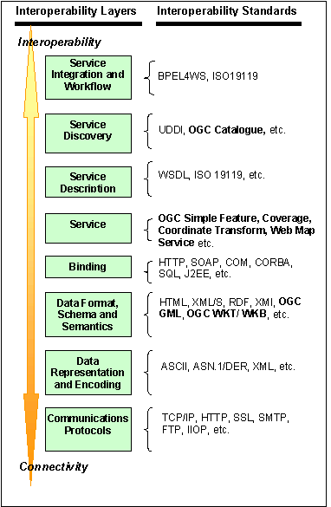
The component-based approach will deliver robustness, functionality and efficiency gains to SLIP collaborators. Standards-based implementation ensures that each component can be the most cost-effective for each particular SLIP-dependant business circumstance. It can incorporate emerging technologies and online services, and does not compromise the future ability of SLIP, as a whole, to meet often-unanticipated future needs. See also Appendix 2:A discussion of Components-Based Modeling.
Figure 2.4: OpenGIS Standards and their Distinct Roles

SDI Standards, Protocols and Specifications
The GSDI is enabled by common standards and architectures which are developed / endorsed by international, national and voluntary standards organizations, and is fueled by widespread agreement on common approaches in many fundamental Spatial Data Infrastructure development and implementation practices.
The standards underlying SDI are in many cases precisely those already accepted and underlying the design and operation of the Internet, the World Wide Web and associated facilities. The standards, specifications and protocols underlying the SDI’s apply at many conceptual levels analogous to the OSI network ‘stack’ (see Figure 2.4) i.e. from low-level communications protocols through data formats and semantics through to service definition, description and discovery to service orchestration for workflows.
The coordination efforts of the GSDI Association (formerly the Global Spatial Data Infrastructure Steering Committee) are leading the GSDI to clear form and substance.
- Standardized Geospatial Metadata (FGDC, ISO 19115) [8] and OGC Catalog Services [2] are defined,
- A network of Spatial Data Clearinghouses is operating on common standards based protocols (z39.50/ ISO 23950 [9]. Over 270 servers are operational, including more than 20 operated by Australia state and federal authorities such as the AASD, and the Canadian spatial data infrastructure GeoConnections service;],
- The current OGC Catalog Service Implementation Specification (ver. 1.1.1) specifies interfaces with existing z39.50 (ISO 23950) FGDC clearinghouse-type metadata catalogues. This stateless protocol does not support the full “publish-find-bind” model although standards-based work-arounds have been demonstrated. Version 2 of the OGC specification will support binding and will be available for implementation in SLIP.
- Clear – and in many cases formalized - liaison relationships between spatial data standards bodies and their counterpart organizations in fields such as international standards definition (ISO), internet (IETF), web (W3C) specification, and e-commerce, and business (OASIS);
- An emerging agreement on a set of core application schema to be available globally as a basis for SDI linkage, for common use in spatial data applications, and for further attribution and densification for larger scale use. SLIP will implement the necessary standard interface with these.
Appendix 5: Specifications and Standards portrays the inter-relationship amongst these standards and the status of their relative implementations and uptake in commercial and open-source software.

Authentication and Access Control
The OGC Distributed Access Control System (DACS), a standards-based infrastructure being defined and tested within the OGC’s Interoperability Program, envisions jurisdictions sharing web services with users within the same or with other jurisdictions in a controlled way. DACS is not yet available for operational implementation but is expected to mature in time for SLIP.
For the purposes of SLIP, a jurisdiction is an administrative entity such as a WALIS collaborator that has the ability to:
- Authenticate its users;
- Provide web services; or
- Both authenticate and provide web services.
An organization – either within WALIS or within commercial or community ranks - may correspond to a single DACS jurisdiction; alternatively, each department, lab, or workstation within an organization may be a separate DACS jurisdiction. Each jurisdiction runs a DACS server, associated with a web server, that is the jurisdiction's initial point of contact for users and other jurisdictions that request access to web services that are under the auspices of its DACS.
DACS provides infrastructure and support for Single Sign-On and access control to jurisdictional web services. SLIP may therefore be implemented with one or many such sign-in points. Having been successfully authenticated by one jurisdiction, a user may then access web services at any jurisdiction within an information community, subject to restrictions on those resources established by their administrators.
Interacting with existing authentication systems, DACS provides a uniform way for users to identify and authenticate themselves. DACS aims to support virtually any authentication method that can be implemented as a web service. By indirectly invoking existing authentication services, DACS avoids the significant administrative task of creating and maintaining a user account for the same user at multiple jurisdictions. This is particularly important in collaborative communities of peers such as SLIP where institutional autonomy must be respected. It is also important to SLIP since it allows for streamlined management of remote users. For example, DLI might establish a joint agreement with the US Geological Survey to recognize each other’s authorized users. For DLI this would mean that a single policy instance could facilitate thousands of authorized users’ access to WALIS controlled-access services. Conversely, DLI staff already registered locally would be recognized in USGS controlled-access systems, without having to re-register. Parallel systems could manage the invoicing and billing exchange between DLI and USGS.
Users can be authenticated in exactly the same way as they already are being authenticated by their jurisdiction, while introducing custom authentication procedures used only in conjunction with DACS. For users, a Single Sign-On eases the burden of having to remember multiple account names and passwords.
The jurisdictions within an information community share certain configuration information and a common Internet domain name suffix. In general, they are expected to honour each other's authentication services. It is assumed that there is an authority within each information community that is responsible for administrative functions, such as assigning unique names to its jurisdictions, managing DNS aliases for the jurisdictions, issuing cryptographic keys and certificates, and so on.
DACS is structured as a set of web services, which are themselves under the access control of DACS. One or more web services are invoked to perform User authentication. There is nothing to prevent the OGC DACS specification from evolving to incorporate newer web services technologies, however. If their use is mandatory or even desirable for OGC web services, DACS can be enhanced to use the Simple Object Access Protocol (SOAP) [38] for describing its messages and the Web Services Description Language (WSDL) [40] for describing its services. To some extent, interoperation with "foreign" identity and authentication systems can be accomplished by developing gateway services. The DACS framework aims to be highly versatile in this respect. Such a service would convert credentials obtained from a non-DACS system to the DACS format, and vice versa.
The Security Assertion Markup Language (SAML) [14] is an XML-based technology under development that promises to effectively do just that, promoting interoperation among different security services. Adding SAML services to DACS would likely involve few changes to the DACS architecture and would allow user credentials produced by DACS to be exported to other security systems and vice versa.

Registry Services
SLIP is designed as an open, distributed, service-oriented system. Its success hinges on clients’ practical ability to locate, access, and use online resources. A registry service is a software component that supports the run-time discovery and evaluation of arbitrary resources such as services, datasets, and application schemas. Dynamic, heterogeneous environments such as SLIP benefit by allowing late binding between service requesters and service providers; that is, allowing that a client will generally not know in advance where a desired resource is located.
A SLIP metadata registry traffics in the information needed to clearly describe, relate, and classify resources offered by SLIP collaborators. A registry service enables the sharing of information between interested parties for the purpose of discovering and exploiting many kinds of resources; the shared information is maintained as objects in a repository that is managed by the registry.
The discovery of resources pertaining to geospatial services and data requires ready access to several forms of metadata:
- Resource-based metadata that describes services, data sets, images, schemas, presentation rules, spatial reference systems, and other shared resources;
- Subject-based metadata that classifies resources according to various schemes (i.e., taxonomies of resource types);
- Links or associations between interdependent resources (or portions of resources);
- Annotations—perhaps transient—that are attached to a resource for a specific purpose or community of users.
A SLIP Services registry that can accommodate all of these forms of metadata will support a wide variety of discovery scenarios that involve multiple communities of practice. In effect, a registry plays the role of ‘matchmaker’ in a service-oriented architecture: providers advertise the availability of their resources in a registry, and users can then query a registry to discover resources of interest and determine how to access them.
SLIP, as a service-oriented architecture must support some fundamental interactions: registering service offers (publishing) and returning service offers upon request according to some criteria (finding). The Registry service provides interfaces for querying and managing a metadata repository; a Registry Client is an application used to query the registry and submit items to be registered.
The OGC registry information model (ogcRIM) is based on the ebXML registry information model (ebRIM, v 2.1) [12], and thus makes the following assumptions: 1) all access to registry content is performed through the interfaces defined for the Registry Service; 2) the information model provides a basis for interoperability by constraining the behavior of the registry (i.e. it helps the implementer to understand what to build by defining the kind of metadata being manipulated and how they are interrelated and packaged); 3) the registry makes use of a repository for storing and retrieving persistent information and shared resources; but no assumptions are made concerning the exact nature of the repository or its location.
Adopting a broader perspective, a registry service can be viewed as a type management system that fulfils a basic repository function in open, distributed systems. It can
- Provide persistent type information for use in service and resource discovery;
- Facilitate dynamic (i.e. late or run-time) binding to service instances;
- Provide support for run-time type-checking for system robustness;
- Be linked to—or federated with—other registries.
Every registry instance implements an information model that provides a high-level schema that defines what types of objects are stored in the registry and how they are organized. Prominent models within the web services realm include the ebXML registry information model (ebRIM) and the UDDI data model. The application programming interfaces associated with both models support multiple query patterns: browse and drill-down (by category), or filtered queries against specified registry objects. However, the ebRIM is more general and extensible—it draws on the ISO 11179 set of standards to provide comprehensive facilities for managing metadata. The UDDI model focuses on business entities and associated service descriptions.
Appendix 4: Services Registry Sample Content provides an example from the Canadian Geospatial Data Infrastructure’s Geoconnections of the types of content stored in a service registry record.
The UML component diagram Figure 2.5 displays the public interfaces exposed by a service instance that conforms to the ‘WRS Provider’ conformance class. The WRSTransaction and WRSQuery interfaces encapsulate the ‘publish’ and ‘find’ interactions, respectively; these “pure OGC” interfaces can be mapped onto the registry information model with few complications. Some minor extensions to the OGC query syntax can be used to simplify such a mapping (e.g. traversing links or specifying complex multi-type queries).
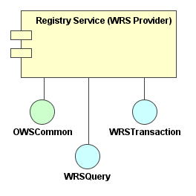
Figure 2.5: Interfaces for the ‘WRS Provider’ conformance class
OGC Catalogue specification describes interworking catalogue services, where a ‘source’ catalogue consolidates responses from other ‘target’ catalogues. The catalogue implementation specification briefly addresses the topic of distributed searching in the context of a stateful catalogue service inspired by the Z39.50 protocol; various query parameters (e.g. queryScope) may be used to control distributed search behavior. This specification does not currently propose a mechanism for propagating queries among registry peers—such functionality remains a future work item for the Technical Committee of OGC in collaboration with W3C and OASIS. Such a mechanism would permit a registry to locate and query other registries, thereby enabling the specification of a search horizon through the use of a distributed search policy.

Future options: Interworking of registries
The OWS1 Web Registry Service Interoperability Report describes a registry that may be completely isolated from other registries, or it could interwork with one or more affiliated registries. Interworking—or federation—refers to the communication and exchange of information between two or more autonomous systems. When a service registry is linked to another service registry, it makes the offer space of the affiliated registry implicitly available to its own clients without loss of individual autonomy. This is contemplated functionality that awaits implementation, yet is recommended to be borne in mind as for future functional flexibility and custodian autonomy as SLIP is designed and implemented.
Registry nodes in peer group
Client node
Figure 2.6: Federated Registries
A SLIP federation of registries would reflect a peer-to-peer architecture, such that each client connects to a single registry as its point of contact with the federation; that server node does not need to be aware of every other registry in the federation, as queries are propagated between peer nodes (Figure 2.6 above).
Each registry has a search horizon limited to those other registries to which it is explicitly linked. As this horizon expands, a large number of registries are reachable from a given starting registry. It is not necessary for a client to know if service offer information is distributed, where the information is held, or the details of any remote registry. A client of a registry that can interwork with other registries binds to only one registry and transparently accesses other registries in the federation via established links. Within an established peer group, each registry has complete control of its policies. In particular, each registry determines its own search policies.

Positioning SLIP for the global spatial data infrastructure

The GSDI is made up of an array of local, national and regional spatial data infrastructures supporting user's needs for spatial data and services. SLIP will facilitate the business interoperation of Landgate and related Western Australian departmental service portals via their departmental interoperability interfaces.
Internet
SLIP
WALIS Agency DII
Customer Management
Authentication
Authorization
Invoicing etc.
Data Discovery Services
Production
Services
Datasets & maps
Images
etc.
Customer Database(s)
Catalogues, Registries
SDE, image databases
World of SDI
SDI’s support a wide variety of user applications. They maintain consistent growth in their utility through user interaction and constant infusion of new or refreshed data resources and an improving set of services and applications. Departmental applications will be available via SLIP enabled interfaces to contribute to this growth in utility of and demand for high-quality geo-related information services.
OGC promotes the emergence of a common geo-processing technology architecture for use around the world for spatially enabling government and business enterprises. SLIP will be consistent with the context of this common architecture.
Each Departmental service manifests that department’s policies and statutory requirements for customer management: user authentication, authorization, utilization tracking, billing etc. These will be leveraged to provide services at the interface between SLIP, representing the GSDI world, and the internal customer management mechanisms. A Departmental Interoperability Interface (DII) will be deployed and configured as appropriate. Specification of the DII for each department is too specifically dependant on their current service infrastructures and so remains beyond the scope of a notional architecture. However their principles can be envisaged in broad outline on the basis of the standards and protocols discussed in the following.
Figure 2.7: Departmental Interoperability Interfaces from WALIS services to the GSDI
The mechanisms will employ open communication content structure standard specifications such as ebXML (promulgated by UN/CEFACT and OASIS, [11]. Open messaging protocols such as the Simple Object Access Protocol (SOAP) [38], the Universal Discovery Description and Integration (UDDI) [15] or the Lightweight Directory Access Protocol (LDAP) [36], could mediate these although precise specification could only be determined once a clear commercial model had been established for SLIP. The selected messaging protocol could be further augmented with certification and encryption capabilities such as the Public Key Infrastructure [13].
An example of an area in which these standards and technologies are converging is the United Nations. Working in part with the OGC, the UN’s Geographic Information Working Group is brokering the development of implementation models for creating an interoperable architecture spanning the geo-data holdings spread across the large number of institutions, systems and administrations that make up the UN. The first step of this implementation is to be a geo-services portal providing service access across this community of organizations, for which a request for proposals has already been published. The RFP specifies and requires OGC-specified interfaces and open standards. An OGC-compliant SLIP will be thus able interoperate with UN-based services i.e. Western Australian data and services to be known to the UN community, and UN-based assets known to Western Australian clients.

Examples of Services Available to SLIP through the GSDI
The Canadian Geospatial Infrastructure is currently under development, with various services at operational, prototype and design stages. Potentially (and within the bounds of CGDI national and institutional policies regarding data and service access) any or all of these may be invoked through SLIP services. For example, the need for a Geolinking Service for SLIP (i.e. the ability to link up tabular data so as to be able to present it as a map) would not necessarily require a WALIS collaborator to implement and support such a thing; instead, the CGDI Geolinking Service could be seamlessly invoked by a SLIP service on behalf of a SLIP user, and the results returned.
While this type of SDI interoperability capability is not necessarily relevant to core Western Australian features of SLIP – a Canadian gazetteer is not very likely to be much good for SLIP’s Gazetteer Name Service – it is of considerable importance for more generic and/or less-frequently required services. It also means that SLIP partners will be able to prototype services for little or no development cost so as to ascertain their demand and capabilities. Performance considerations, service availability and other considerations might lead a WALIS partner to decide to implement the service locally, but at least the decision would be based on facts and experience rather than speculation.
See” Appendix 3: Examples of GSDI-enabled services - the CGDI” for examples of the types of web-enabled services provided in a well-featured SDI.

Positioning SLIP for the Australian spatial data infrastructure ASDI - hooks
DLI is one of the contributing agencies to national infrastructure projects including the Australian Spatial Data Infrastructure initiative, a “…national framework for linking users with providers of spatial information and is similar in concept to a national highway or railway network.” envisaged to ensure that Australia's spatially referenced data, products and services are available and accessible to all users.
The ASDI comprises the people, policies and technologies necessary to enable the use of spatially referenced data through all levels of government, the private sector, non-profit organisations and academia. ASDI technologies are consistent with the standards and protocols of the GSDI.
Numerous WALIS collaborators publish metadata content into the ASDD, the Australian Spatial Data Directory (ASDD), a key component of the ASDI. The ASDD provides spatial metadata search and retrieval implemented through GSDI-approved standards and protocols, the z39.50/ ISO 23950 distributed search and retrieval protocol against FGDC/ISO 19115 spatial metadata. SLIP will continue and expand the capability for WA government departments and collaborators to interoperate with the ASDD and future components of the ASDI.

WA Spatial Infrastructure
Western Australia already hosts elements of a mature spatial data infrastructure in the form of the WA Land Information System, WALIS. WALIS has been established on the principles of distributed information services provided by numerous custodians participating in a peer-based management and operational structure. Prototypes and demonstrators of integrated mapping services based on OpenGIS specifications have demonstrated the feasibility of orchestrating cooperation amongst state bodies for public information service. WALIS ‘discovery’ services provide single-query search and retrieval across agencies although metadata are presently hosted from a single centralized server.
SLIP will provide a number of benefits building on the WALIS foundations. These will include:
- Frameworks for implementation of services beyond ‘simple’ mapping of spatial data currently implemented through web map services, including feature services, enhanced find-and-bind to remote services, structured service registry management, and service utilization accounting;
- An institutional framework able to secure each custodians authorities regarding service and access policies, including cost-recovery;
- An community sharing common service experiences able to leverage and boot-strap the efforts of new participants less motivated by the technical challenges of emerging technologies, especially in community and public-good spheres.
No element of the existing WALIS services will be compromised by implementation of the proposed SLIP architecture.

Recommendations Arising from Notional Architecture
We recommend that the phased implementation plan should:
- Commence with identification of a host for the initial SLIP Registry of Services implementing the OpenGIS WRS specification;
- Follow immediately with implementation of other required core services especially a geographical name information service (gazetteer) implemented through OpenGIS WFS;
- Further elaborate interfaces to services to interoperate through SLIP from hosts in other state, federal, commercial and community hosts, both in Australia and abroad;
- Commence a programme for incremental definition, demonstration and implementation of standards-based user audit and management services to be ultimately interoperated with partners’ user management services;
- Commence a programme to support WALIS agencies’ implementation of interface elements, middleware and wrappers over existing legacy land information services so as to support OpenGIS-specified interoperability interfaces.
SLIP will enable WA government departments and collaborators to interoperate with existing and future components of the ASDI especially the Australian Spatial Data Directory (ASDD), which is provides spatial metadata search and retrieval implemented through GSDI-approved standards and protocols, the z39.50/ ISO 23950 distributed search and retrieval protocol against FGDC/ISO 19115 spatial metadata.

WA Infrastructure trends
Conformance with the GSDI and ASDI has been accommodated. Further layers of conformance will also be required.
Commonwealth and State governments are undertaking a rationalisation of information and communications infrastructures. Reference for the initiatives is provided by the e-Government Interoperability Framework. The e-GIF base set of policies and standards guidelines are to be published by NOIE July 25th as a precursor to discussion by the Information Management Strategy Committee (http://www.imsc.gov.au/index.htm) in October 2003. WA, through the Office of E-Government within the Department of the Premier and Cabinet, is preparing base policies and standards, as a result of consultation with NOIE and over 60 Agencies and interested parties. The report is due for release in August 2003.
WA is also keeping a watching brief on efforts in NSW (Office of Information Technology) in relation to standards harmonization. Relevant to this study is a recent report is which compares AS 4590-1999 and AS/NZS 4819-2003 and the OASIS CIQ standards. AS4590 concerns client data interchange standards and AS/NZS 4819 Street Addressing. AS/NZS4319 supercedes AS/NZS 4724-2000 Geographic Information - Rural Addressing.
Interchange of client and address information will be essential message transactions for SLIP not only for authentication and bill presentment but also for participation with other communities of interest when supporting critical infrastructure applications. Critical infrastructure applications include, for example, internal and cross boarder security, boarder control, off-shore fisheries surveillance, immigration/migration, taxation, land tenure and emergency responses including epidemiological issues e.g. SARS, foot and mouth, agricultural pests such as locusts, and pollution e.g. oil spills.
Further demands will be placed on SLIP as the State integrates business and regulatory processes for planning and infrastructure and adopts broader consultative processes for land use, for example, the Burrup Peninsula.
Data consistency and interoperability are being sought within the Human Services and Health Departments as the requirements for data cleansing, service/resource planning and reporting are involving spatial data increasingly.
The SLIP notional architecture has taken these issues into consideration.

Notional architecture - E-services and Interoperability as per OGC Reference Model

The Enterprise Viewpoint
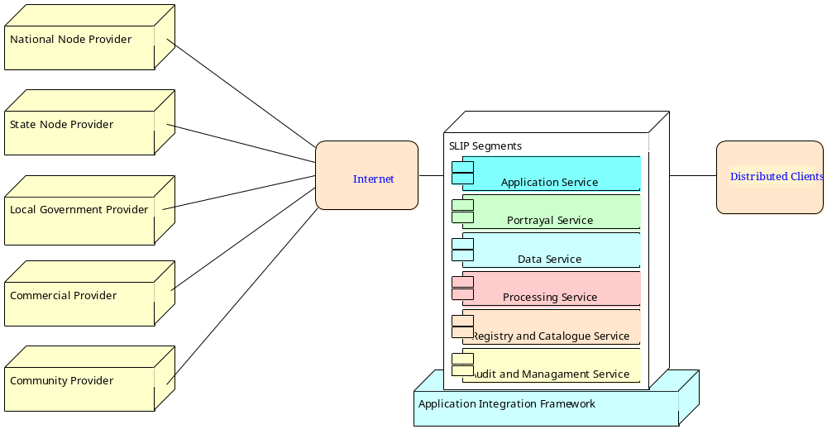
Figure 3.8: Envisaged SLIP Major Enterprise Segments
SLIP is envisaged as an internet-enabled backbone connecting clients to services provided by autonomous service custodians via an internet-enabled backbone. SLIP’s enterprise segments are defined to mediate, manage and account for these connections, as indicated in the above figure 3.1
Elaborating the enterprise segments requires that the characteristics of these service custodians and their business models be made explicit:
- Each service custodian provides to the WALIS community those services consistent with its institutional mandate and priorities
- Service custodians’ business tasks require delivering geo-data and derived products to clients.
- One or more service custodians may elect to stand up an umbrella portal for clients to access SLIP-mediated services. Conversely, each service custodian may provide a portal for clients to access all other SLIP-mediated services.
- Custodians may elect to jointly utilize common services where indicated by economies or scale, existing infrastructure or in-house expertise.
- Service custodians may be within the government or commercial sectors, or within civil society.
- Service custodians need not be operating at state or intra-state level.
- Products and services may be available at cost or at no cost.
- Authoritative service custodian institutions determine pricing policy.
- Products, services and policies are published to catalogues and registries.
Similarly, custodians’ clients’ characteristics need specification:
- Clients may be people or remote processes.
- Clients may originate anywhere on the Internet, and are not restricted to those solely within Western Australia
- Clients may be billed for products and the services used to produce them. Many providers operate services and generate products.
- Clients may be billed according to the charging policies or one or more service/ product providers.
- Clients may be required to be identified and authenticated before being authorized to use services or receiving valued products.
- Clients use of services may be monitored for capacity assessment and planning, for billing, for QOS audit. Each institution may need to exchange monitoring data for QOS and invoicing purposes.
Failover and recovery strategy – a community of peer service providers mediated via SLIP provide and extremely robust model for failover and fallback recovery; loose coupling and failure of any single service need not mitigate against the whole community; able to queue and roll forward transactions upon resumption of service.

Essential Enterprise Usage Scenarios
Initial indication of representative use cases for the tasks to be mediated across the SLIP interface, including
- Client request servicing
- Client management, such as authorization and invoicing
- Service publication and usage guideline definition
- Service accounting for QOS, capacity planning and invoicing purposes

Main Actors

Service Custodian actor
The Service Custodian actor is responsible for providing, maintaining and deactivating one or more services available to SLIP Client actors
This actor may or may not be the same as the custodian of the data used by a particular service - SLIP only “sees” data as the result of a service that delivers, portrays or otherwise manipulates those data and as such the SLIP client has no direct relationship with data custodians.
The Service Custodian actor articulates the Service Use Policy to be implemented by the Service Accountant actor and the Client Manager actor
The Service Custodian actor publishes the existence of a service to a Registry Service
The manager of the Registry Service is also a Service Custodian.

Client actor
A Client actor may be a human or remote system using services mediated through SLIP. This includes use of brokerage, billing and references as well as substantive content.
A Client actor seeks and identifies services through the published information provided by the Service Custodian actor.
A Client actor may need to be authorized to use a services, and may be invoiced for its use, according to policy established by the Service Custodian actor.
Figure 3.9: Representative SLIP process management and utilization use cases

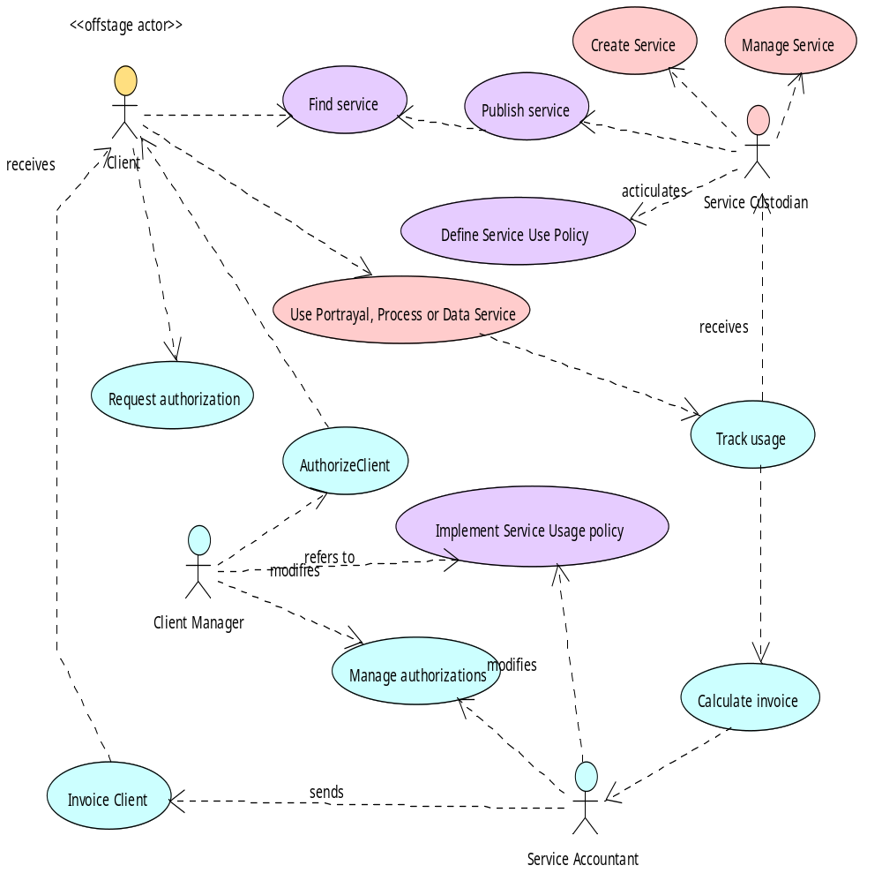
Service Accountant actor
The Service Accountant actor implements invoicing of Clients use of services according to the usage policy articulated by the Service Custodian actor. The Service Accountant actor generates invoices against Client actors and accounts for payments received
The Service Accountant actor may be an automated agent.
The Service Accountant may signal the Client Manager actor of shifting requirements for authorization of a Client actor on the basis of invoicing history.

Client Manager actor
The Client Manager actor manages each Client actor's authority to use each Service according to the Service Use Policy articulated by the Service Custodian and, if necessary, accounted for by the Service Accountant actor.
The Client Manager actor modifies authority according to the requirements of the Service Custodian actor and the Service Accountant actor.
The Client Manager actor may be an automated agent.

Main actions

Publish service
The Service Custodian publishes knowledge of the existence of a Service to a Registry Service. This knowledge includes pertinent elements of the Service Use policy.

Find service
The Client actor identifies relevant services through Registry Services containing information published by the Service Custodian actor. This includes service parameters as well as Service Use policy.

Request authorization
The Client actor identifies relevant services through Registry Services containing information published by the Service Custodian actor. This includes service parameters as well as Service Use policy.

Define Service Use policy
The Service Custodian actor articulates Service Use Policy that determines the types of Client actors that may use a Service, the level of service under various conditions, and at what cost to a Client actor. The Service Accountant actor implements the financial policy. The Client Manager actor implements the authorization policy.
Service policy may require password authentication before a Client actor can use a Service.
Service Use policy may include free-to-air services available to unauthorized Client actors.
Service Use policy may include recognition of authorities granted to a Client actor already authorized to use services in a remote system with which SLIP is collaborating.

Implement Service Use policy
Service Usage policy articulated by the Service Custodian actor is implemented by the Service Accountant actor (if the case of services entailing invoicable costs to Client actors) and/or the Client Manager actor (in the case of services requiring Client actors to be authorized for use.)

Service usage Accounting
Service usage is tracked for all Services even if no Client actor requires authorization to use the service or if no Client actor is invoiced for use of the service. Usage statistics for each Service are provided to the Service Custodian actor for Quality of Service audit and capacity planning purposes.

The Information Viewpoint
The information viewpoint is used to specify the meaning of the information stored with and manipulated by the SLIP community, independently of the actual distribution within the community.
The Geo-spatial objects considered to be of relevance in the WA context include, for consideration:
- Geographic features,
- Geographic coverages,
- Geographic measurements,
- Spatial reference systems,
- Geographic transformations,
- Geographic projects,
- Geographic events,
- Map styles and symbologies, and
- Other representation systems.
The SLIP information viewpoint leaves, for later further elaboration, the descriptions as to where these entities are currently reposited and under which custodial authority.

The Computational Viewpoint
The Computational viewpoint addresses the question “How the jobs to be done within SLIP should be partitioned into functional components”? In some instances these are pre-defined by the legacy systems that have already been engineered. Task of this analysis includes identification and abstraction. Figure 3.10 summarizes the computational elements underlying the implementation of the “publish-find-bind” model represented in the SLIP architecture.
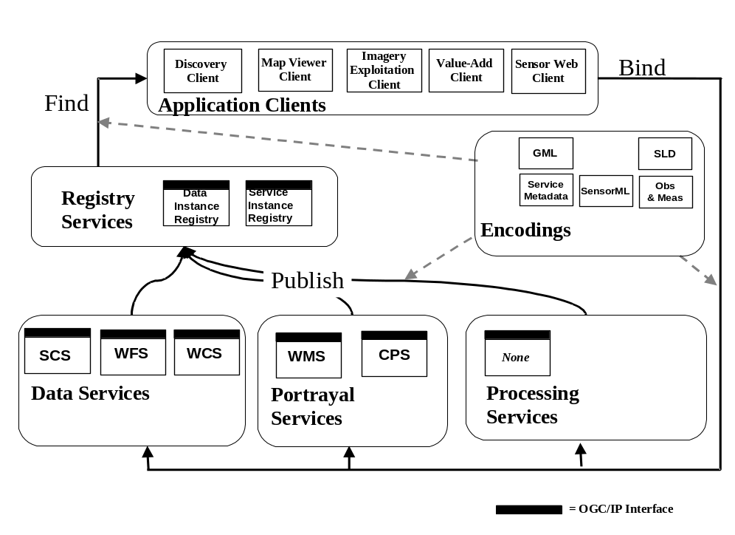
Error: Reference source not found (below) depicts a summary of the major packages envisaged for SLIP and the interface relationships amongst them. This notional architecture leaves for later development the identification of the binding models between interfaces, and the Quality of Service implications.
Figure 3.10: Computational Elements of SLIP
Each high level object, represented as a package containing a cluster of related objects, which, when implemented, may be distributed across the infrastructure. Some high level objects are at the client level for visualization, some are at the application server level for processing, and some are at the database or repository level for storage and access.
Typically, one can expect to find the data identified in the Information Viewpoint associated with these objects in various types of repositories, or Spatial Object Databases. These include:
- Feature Databases, i.e., geographic feature servers;
- Coverage Databases, including imagery and other types of spatial distributions;
- Map Style Libraries;
- Geographic Event Databases;
- Map Symbol Libraries;
- Geographic Measurement Databases, e.g., surveys, hydrographic and oceanographic measurements, and;
- Spatial Reference System Dictionaries.
These geospatial objects are examples of elements of the infrastructure that would be utilized by many client applications. The purpose of SLIP is to make the interfaces to these objects available to clients and providers with seamless views of the information.

The SLIP Service Design Concept
SLIP services have these characteristic roles and responsibilities:
- Provide valued service to clients
- Are managed by service custodians, who may or may not be the data custodians for the content of the service.
- Are subject to usage policies, formulated by the service custodian, concerning clients’ access authority the cost of using the service
- May or may not be existing legacy systems
- Are presented through appropriate OpenGIS interfaces.
- “Data extraction and delivery” is an instance of a service i.e. that data values do not need to be modified to constitute a process.
- Registries and catalogues are instances of services i.e. they are not restricted services related to geo-spatial data.
The SLIP summary design concept (see Figure 3.11 following), implementation of SLIP will devolve to seven main packages, in turn comprising an unknown number of specific modules that will depend, in part on the balance between cost-effective centralization and distributed autonomy sought by the WALIS collaborators.
It must be emphasized that the intention is that this design be implemented incrementally and in a distributed manner. Furthermore:
- The Processing Services shown are indicative; decisions regarding which services to implement and present via SLIP will be made by individual custodians according to their business requirements and mandate;
- Application services are expected to be delivered to remote application systems as well as to people; people may be using thin clients (web browsers), thick clients (OGC-compliant desktop GIS systems) or ‘chubby’ clients including mobile computing platforms, PDAs, and WiFi clients.
- With the exception of the services registry, each of the design components may be represented more than once in an operational SLIP;
- Elements shaded grey are ones for which OGC specifications are anticipated or under development but not yet promulgated, and hence can be represented but not yet implemented;
- Data repositories in many cases already exist and are operational services within WALIS collaborating agencies. These services may be ‘wrapped’ with lightweight standards-compliant interfaces in order to participate in SLIP.
- The Gazetteer Service is assumed to be an elaboration of the GEONOMA database (maintained by the Geographic Names Committee) served as an OpenGIS WFS-Gazetteer.
As per the design concept summary (see Figure 3.11 following), implementation of SLIP will devolve to seven main packages, in turn comprising an unknown number of specific modules that will depend, in part on the balance between cost-effective centralization and distributed autonomy sought by the WALIS collaborators.
The seven principle packages are:
- Application Services, comprising the web Map Viewer client interface, the Discovery Client Interface, the Gazetteer Client Interface and the Publisher Interface;
- Registry and Catalogue Services that support the Discovery Client through search and retrieval of the descriptions of data sets, services and other entities referred to in the various registries. Search parameters may include text, keyword, time and spatial location.
SLIP will for present have a single Services Registry (though plausibly multiple data catalogues) since the OGC WRS specification does not yet support registry federation. The Services Registry is the ‘heartbeat’ of SLIP and must have high availability, reliability, integrity, security and performance.
The WALIS community will need to carefully select an appropriate custodian for this critical service.
- Audit and Management Services, which provide for end user authentication, authorization and access control according to policy promulgated by Service Custodians, plus accounting information support cost recovery, QoS assessment, audit trails and capacity planning;
- Data Repositories, which comprise substantive geo-data sources including file servers and spatial databases providing access to both spatial data and aspatial data, as well as storing the information required by the catalogue and registry services, the gazetteer service and the Management and Audit Services;
- Portrayal Services, which render (using WMS and possibly other applications) geo-data in forms suitable for the Map Viewer Client, based on the contents of various data repositories both local and remote;
- Data Services, which extract and abstract the content from Data Repositories for delivery to ‘chubby’ and ‘thick’ clients that are capable of utilizing GML-mediated WFS and WCS outputs. The Gazetteer Service is also one of SLIP Data Services;
- Processing Services, the precise nature of which cannot be elaborated but may include reprojection, generalization, modeling, geolinking and other types of processes manipulating data delivered from various Data Services for delivery to either Data Services to ‘chubby’ and thick clients. The WALIS community will identify or designate custodians for each process.
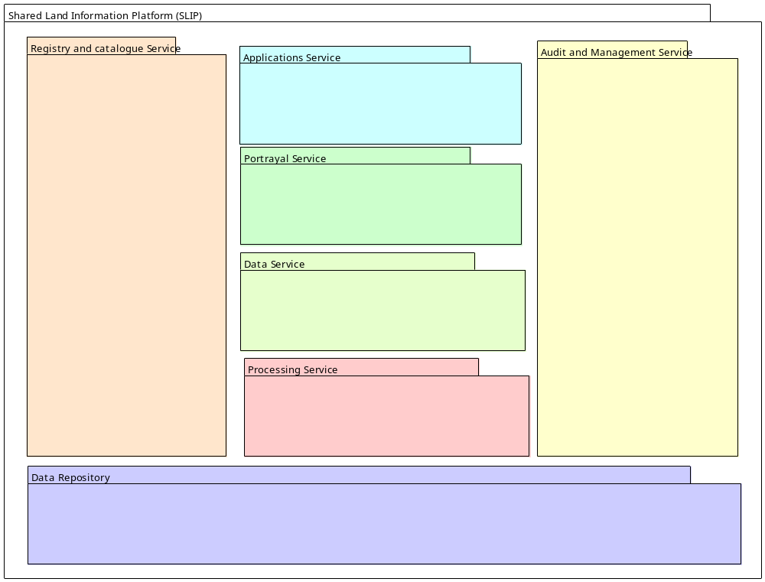Figure 3.12: Major SLIP Packages indicates the relative functional relationships amongst these packages, most importantly the crosscutting nature of the Registry and Catalogue Services and the User Audit and Management Services. It will be for the WALIS community to determine the priority and sequence in which elements of these packages are implemented; Figure 4.20: Notional SLIP Component Implementation Sequence and Capability Dependencies following indicates the functional dependencies amongst package elements that will need to be borne in mind as these priorities are assigned.
Figure 3.11: SLIP Services Design Concept Summary
Figure 3.12 (following) presents a fully-elaborated SLIP design concept based on the open web services principles described above, and drawing upon experience gained in other jurisdictions in rolling out operational SDI elements.
Each of the major packages portrayed in the summary design concept has been broken out to varying levels of detail to indicate (where possible) specific service objects anticipated to be required within the cluster; in other cases (shown by white symbols) suggestions are offered as to the some of the service objects required, but these are intended to be neither proscriptive nor inclusive.
It must be emphasized that the intention is that this design be implemented incrementally and in a distributed manner. Furthermore:
- The Processing Services shown are indicative; decisions regarding which services to implement and present via SLIP will be made by individual custodians according to their business requirements and mandate;
- Application services are expected to be delivered to remote application systems as well as to people; people may be using thin clients (web browsers), thick clients (OGC-compliant desktop GIS systems) or ‘chubby’ clients including mobile computing platforms, PDAs, and WiFi clients.
- With the exception of the services registry, each of the design components may be represented more than once in an operational SLIP;
- Elements shaded grey are ones for which OGC specifications are anticipated or under development but not yet promulgated, and hence can be represented but not yet implemented;
- Data repositories in many cases already exist and are operational services within WALIS collaborating agencies. These services may be ‘wrapped’ with lightweight standards-compliant interfaces in order to participate in SLIP.
- The Gazetteer Service is assumed to be an elaboration of the GEONOMA database (maintained by the Geographic Names Committee) served as an OpenGIS WFS-Gazetteer.
Discussion of each of the packages and their service objects follows the diagram.
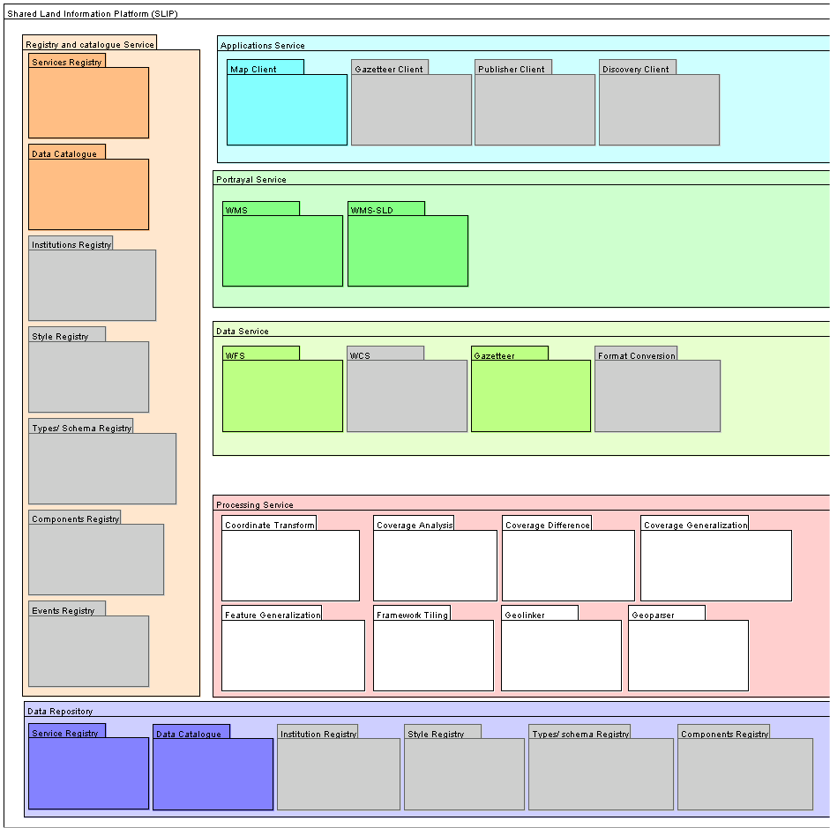
Figure 3.12: Major SLIP Packages

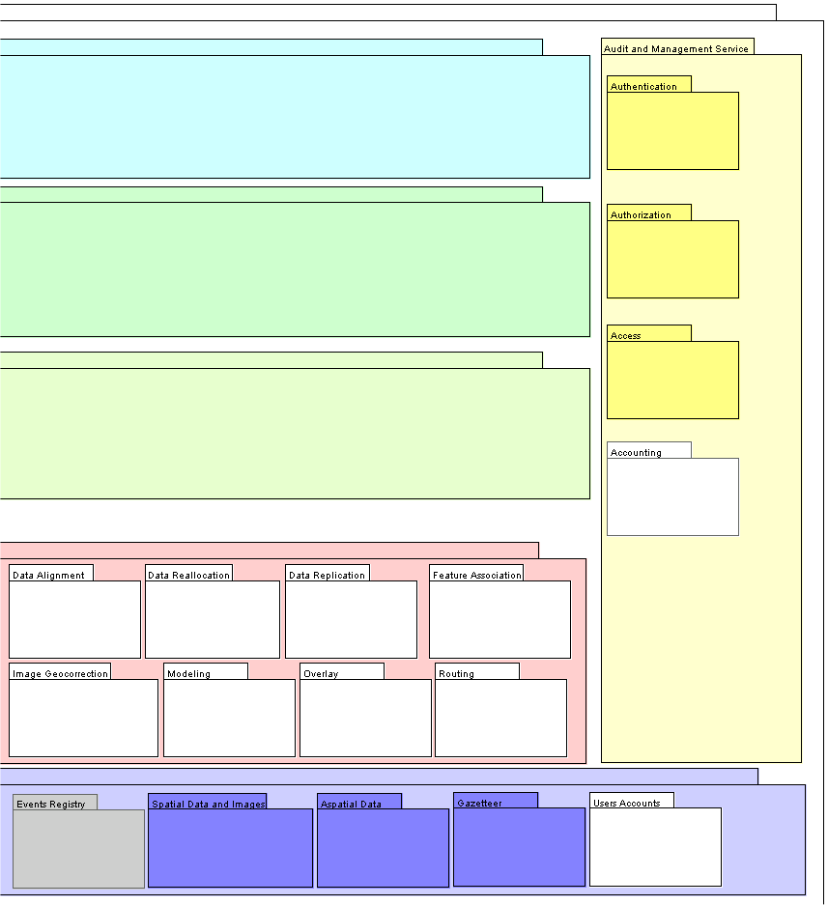
Figure 3.12 (cont.): Major SLIP Packages

Application Services
Provider Services are accessible from Application Services operating on user terminals (e.g. desktop, laptop, etc.) or servers that have network connectivity. The Application Services, along with the Application Integration Framework below, provide the user interface of SLIP. Users may leverage Application Services to access SLIP Registry, Portrayal, and Processing segments and distributed Map and Data Services, depending upon the requirements and designed implementation of the application.
The following characterize the roles and responsibilities of Applications Services in SLIP:
- Provided for human and remote system clients
- All interactions are mediated through the Internet using generic protocols (TCP/IP. HTTP)
- All interactions are mediated by messages in well-structured vendor-neutral formats (XML)
- Human interface interaction (web browsers and other clients) are ultimately realized in the same messaging structures used for remote system messaging
- Human interfaces may be portrayed via thin, thick or ‘chubby’ clients i.e. web browsers, sophisticated desktop applications or web browsers enhanced with additional capabilities provided by substantial chunks of Java add-ins.
- Interfaces will also be portrayed in device platforms such as mobile computing platforms, PDAs, WAP-enabled handsets and WiFi clients.
Several Application Service types are identified. In SLIP, Application Services are realized as, or requested from, web pages transferred across a network from application servers and supported by server-side capabilities to generate various clients and process requests. Thus, each item in the list below is called a "Client Generator" (CG) of some type. Client Generators process requests from Thin Clients, maintain or transfer state between requests, and return responses to the requesting Thin Client. More specifically, when accessed as a World Wide Web application a Client Generator runs on an HTTP server and generates HTML pages to be displayed in the User's web browser (the thin client). In SLIP, Client Generators are termed "server-side" components because they run on computers hosting the SLIP services, not on the end-user's machine or on the data service provider's machine.
- Viewer Client Generator (Priority 1): This is a server-side component that enables thin Viewer clients, e.g., clients that run on standard web browsers. The Viewer Client provides a visualization user interface to display and navigate content retrieved from WMS, WFS, WCS and other services.
- Discovery Client Generator (Priority 1): This is a server-side component that enables thin Discovery Clients e.g., clients that run on standard web browsers. The Discovery Client provides means for users to locate needed data and services according to user-defined criteria. More specifically, in the context of SLIP the Discovery Client Generator will enable the FGDC-compliant Clearinghouse Networks such as the ASDD to be searched within SLIP.
- Publisher Client Generator (Priority 1): This is a server-side component that enables thin Publisher clients e.g., clients that run on standard web browsers. The Publisher Client provides means for Portal maintainers and authorized users to publish services or data in the Local Registry. In SLIP, the Publisher Client Generator will allow authorized users to register Primary information sources, pre-defined symbolization rules, and possibly other information. Publication of dataset metadata in the WALIS Interragator and ASDD Network will presumably be through existing mechanisms, not through SLIP.
- Gazetteer Client Generator (Priority 1): This is a server-side component that enables thin Gazetteer clients e.g., clients that run on standard web browsers. The Gazetteer Client provides users the ability to navigate through spatially organized features with well-known feature names. Gazetteer Clients allow users to formulate queries to retrieve named features. In SLIP, the Gazetteer Client will utilize an agreed Geographic Names Information System such as GEONOMA as a primary database of feature names.
- Data Extraction Client Generator (Priority 1): This is a server-side component that enables thin Data Extraction clients, e.g., clients that run on standard web browsers. Data Extraction Clients provide users the ability to extract features or coverage data from WCS and WFS instances.
- Data Manipulation Client Generator (Priority 2): This is a server-side component that enables thin Data Manipulation clients, e.g., clients that run on standard web browsers. Data Manipulation Clients provide users the ability to access, modify, add, and delete geospatial content stored at remote WFS, and possibly WMS or WCS, instances.
- Symbol/Style Management Client Generator (Priority 2): This is a server-side component that enables thin Symbol/Style Management clients, e.g., clients that run on standard web browsers. Symbol/Style Management clients allow user to browse the styles available from a given server and obtain and apply a predefined style definition for a particular feature type(s).
In SLIP, server-side Components will generate client-side Map Viewer, Discovery, Registration, Gazetteer, Data Extraction, and Data Manipulation Clients within a standard Web Browser. These Application Service components shall provide a human user interface to the underlying service components defined in the following sections. Each of those underlying services shall have an application interface that is documented in the Portal Architecture Specification (or by reference to another specification). Those application interfaces shall be invoked by the Application Service components, and may be used by "thick clients" to bypass the human interface and directly access the convenience functions provided by the Portal. (For example, a desktop software application could use the Gazetteer Connector to access the GNIS, or invoke the Schema Translation Service.) The SLIP Service Custodians shall be able to impose independent access restrictions on each service component.

Portrayal Services
Portrayal Services provide specialized capabilities supporting visualization of geospatial information. Portrayal Services are components that, given one or more inputs, produce rendered outputs (e.g., cartographically portrayed maps) or leverage the parameters of rendered outputs to coordinate multi-source display (e.g. create scale and view-dependent displays). SLIP Portrayal Services are loosely coupled with other services such as Map and Data Services and transform, combine, or create portrayed outputs. Five components are identified:
- Cascading SLD-enabled Web Map Service (Priority 1): This service communicates with Provider WMS instances (both basic and Style Layer Descriptor-enabled) to formulate and possibly execute valid operations to request service metadata, to request maps, or to perform other operations available from the Provider. The Cascading WMS component can transform map formats and map projections. It allows users to discover and select appropriate styles (either named or SLD-based) for each map layer and composes the SLDs so that map portrayal can be requested.
- Coverage Portrayal Service (Priority 2): This service receives coverage data from a WCS or Image Handling System, applies symbolization information in the form of Styled Layer Descriptors, and renders the coverage data for display to the user.
- Style Management Service (Priority 2): This service is a multi-component system that enables map and data retrieval, and includes the capability for creating, storing, and/or retrieving styles and symbols from multiple communities or user groups and combining all these elements of information into an appropriately symbolized map. This service may consist of multiple components including a Style Registry, Style Repository, Symbol Registry, and Symbol Repository presented through a common, standard interface.

Processing Services
Processing Services provide the service building blocks that operate on geospatial data and provide “value-add” services for applications. Three components are identified, but all are priority 2:
- Gazetteer Connector (Priority 1): This component communicates with an external gazetteer to retrieve geometry and other attributes associated with geographic names. This component provides a "wrapper" for a gazetteer instance that does not support the OGC Gazetteer Service interface: it accepts OGC-compliant queries, issues requests to the non-compliant gazetteer, and converts the responses to make them OGC-compliant. SLIP will require a Geographic Names Information System such as an enhanced GEONOMA to be designated as the external gazetteer.
- Format Translation Service (Priority 2): This service transforms the format supported by WFS and WCS instances into a format supported by the client.
- Coordinate Transformation Service (Priority 2): This service allows users and applications to convert a position given in one coordinate reference system into the corresponding position in another coordinate reference system.
- Schema Translation Service (Priority 2): This service allows Web Feature Service to ingest features using one data schema and export that same data using the original or another well known schema. This translation is performed such that the semantic integrity is maintained.

Catalogue and Registry Services
Registry and Catalog Services provide a common mechanism to classify, register, describe, search, maintain and access information about resources available on a network. Resources are network addressable instances of typed data or services. Three components are identified:
- Local Registry Service (Priority 1): This is a registry service that is maintained and operated locally by a SLIP service provider. It is accessible by the Publisher Client Generator. It maintains a list of Primary information sources and their service metadata. It may temporarily cache metadata regarding user-discovered Secondary and Tertiary information sources. It may store predefined SLD documents.
- Clearinghouse Connector (Priority 1): This is a software component that allows the searches of the WALIS Interragator and ASDD clearinghouses.
- Context-Based Discovery Service (Priority 1): As the User navigates (changes the displayed bounding box) while viewing maps of one or more types of data, this service automatically discovers services providing data of those same types in the new bounding box, and allows the user to select them and to de-select services no longer relevant to the user's new bounding box.
The following characterize the roles and responsibilities of Catalogue and Registry Services in SLIP:
- Each service custodian publishes their service to a registry detailing the nature of the service and the policies regarding it use.
- Registry entries are formulated using appropriate OpenGIS registry service forms.
- Each dataset custodian may use the Publisher Client to create and modify ISO 19115/ FGDC compliant data set metadata.

Audit and Management Services
The following characterize the roles and responsibilities of Audit and Management Services in SLIP:
- Clients may be required to be authorized to used a service;
- Authorization and certification are mediated using appropriately well-formed XML;
- Clients may need to be invoiced for using services;
- Usage statistics will form one base for utilization monitoring, reporting, QoS assurance and transaction auditing.

Data Repositories
Data Repositories provide the persistent storage of geographic objects, temporal events, associated aspatial data, user audit and management records, registry and catalogue metadata, and articulated service and data use policies.
For SLIP’s purposes Data Repositories are assumed to:
- Reside at many dispersed sites each managed a WALIS collaborator, commercial partner, community publisher or any SDI-enabled facility residing anywhere on earth;
- Each be the responsibility of a data custodian possessing the technical means, mandate and motivation to competently maintain data content and their associated metadata, and to ensure their reliable availability;
- Each be subject to articulated policies governing the appropriate access, use and cost-recovery for use of data;
- Require, in some cases, on-line transaction-based content update via the SLIP interface.

Data Services
Data Services are the means by which users (including automated processes) acquire copies of data in either original or processed form. This encompasses simple existing facilities for downloading copies of entire data elements such as shapefiles, raster images or database records, as well more sophisticated services delivering data that may have been customized to users’ requirements through Processing Services (see below) such as extraction, abstraction, combination, reformatting, reprojection, merging and so on.
Data services may encompass online transaction-oriented delivery, batch-oriented on-line file delivery, and off-line delivery on physical media. The typical user of Data Services possesses technical expertise in geographic information systems, cartography, statistical analysis or database manipulation and require the data for further processing in ‘thick’ or ‘chubby’ clients systems such as desktop GIS, database and statistical systems.
The Web Feature Service is required Data Service for SLIP.
For SLIP’s purposes Data Services are assumed to:
- Reside at many dispersed sites each managed a WALIS collaborator, commercial partner, community publisher or any SDI-enabled facility residing anywhere on earth;
- Each deliver content in accepted standard content formats and transfer formats. SLIP envisages using the Geographic Markup Language as its transport format.
- Each be the responsibility of a Service Custodian possessing the technical means, mandate and motivation to competently maintain services and their associated metadata, and to ensure their reliable availability;
- Each be subject to articulated policies governing the appropriate access, use and cost-recovery for use of the service;
- Not necessarily be co-resident with any of the Data Repositories underlying the service.

Portrayal Services
Portrayal services prepare visualizations and representations of data originating from Data Repositories and Processing Services. Users receive images representing the data, not the actual data values themselves. These images may be maps, statistical charts, chloropleth depictions, VRML animations or narrative packages such as summaries delivered in PDF format. A common existing Portrayal Service required for SLIP is the Web mapping Service.
Portrayal services are typically required for providing service to ‘thin’ web clients, mobile computing platforms and the likes. The typical user of Portrayal Services need not possess technical expertise in geographic information systems, cartography, statistical analysis or database manipulation that the Data Service user possess.
For SLIP’s purposes Portrayal Services are assumed to:
- Reside at many dispersed sites each managed a WALIS collaborator, commercial partner, community publisher or any SDI-enabled facility residing anywhere on earth;
- Each deliver portrayals in accepted standard graphical and/or text formats and transfer formats. SLIP envisages using Well Known Text, JPG, GIF and PNG.
- Each be the responsibility of a Service Custodian possessing the technical means, mandate and motivation to competently maintain services and their associated metadata, and to ensure their reliable availability;
- Each be subject to articulated policies governing the appropriate access, use and cost-recovery for use of the service;
- Not necessarily be co-resident with any of the Data Repositories underlying the service.

Processing Services
Processing Services conduct transformations of data originating from Data Repositories or other processing Services and may deliver their outputs to Portrayal Services, Data Services or other processing Services.
Processing services may be required for providing service any type of end users. The transformations provided may be geometric (e.g. reprojection), topological (e.g. merging coverages), arithmetic (e.g. statistical modeling), format related or extractive.
For SLIP’s purposes Portrayal Services are assumed to:
- Reside at many dispersed sites each managed a WALIS collaborator, commercial partner, community publisher or any SDI-enabled facility residing anywhere on earth;
- Each deliver content in accepted standard content formats and transfer formats. SLIP envisages using the Geographic Markup Language as its transport format.
- Each be the responsibility of a Service Custodian possessing the technical means, mandate and motivation to competently maintain services and their associated metadata, and to ensure their reliable availability;
- Each be subject to articulated policies governing the appropriate access, use and cost-recovery for use of the service;
- Not necessarily be co-resident with any of the Data Repositories underlying the service.
Figure 3.13: Representative SLIP Process Components (following pages) depicts the envisaged distribution of the capabilities described in the preceding sections. Note that each component capability (with the current exception of the Registry Service) may be manifest in more than one institution, and that the providers of many of these components need not strictly be part of the WALIS community or any other Western Australian community.
Figure 3.13 (following) depicts the interface dependencies any SLIP implementation will need to meet. This provides the basis for the dependencies made explicit in the nominal rollout sequence presented later in Figure 4.20: Notional SLIP Component Implementation Sequence and Capability Dependencies. Of particular significance is the number of Applications Services requiring an operational Gazetteer component.

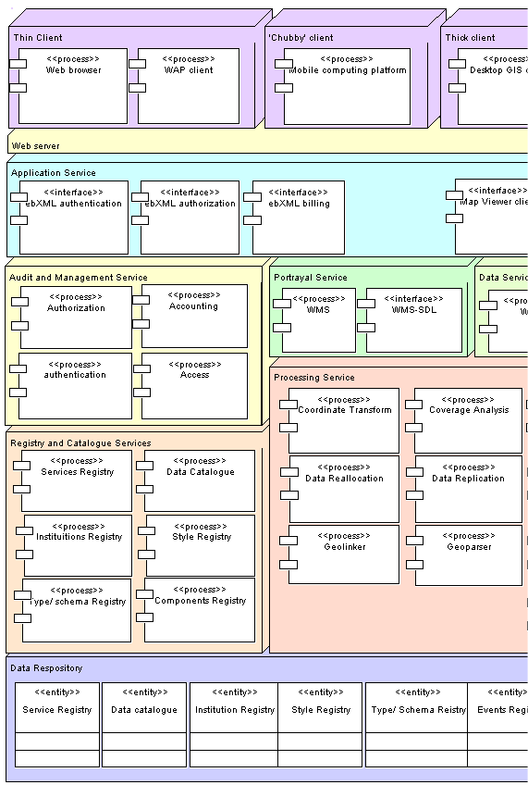
Figure 3.13: Representative SLIP Process Components

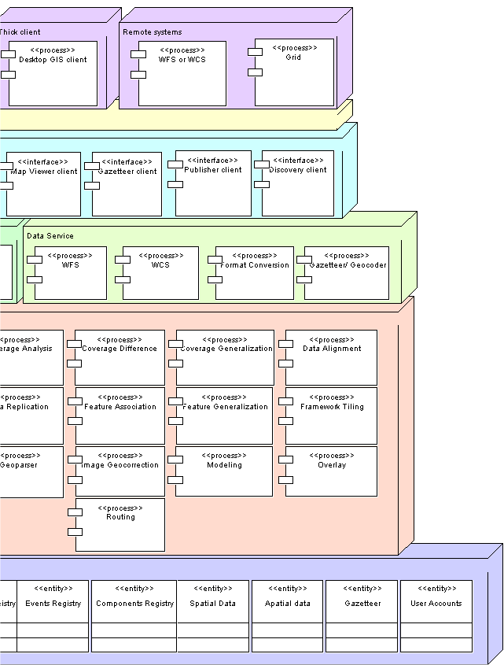
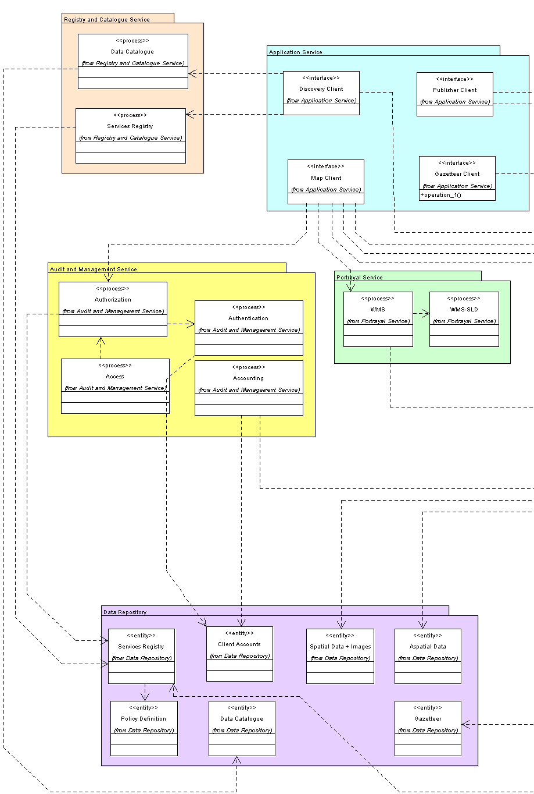
Figure 3.14: Major SLIP Packages, Components and Interfaces



Engineering Viewpoint
This section focuses on the deployment aspects of a system, with explicit depiction of distribution rather than that merely implied in the computational viewpoint. It describes the major segments envisaged as providing the operational components of an implemented SLIP and the forms of their various interfaces.

Application Integration Framework
The Application Integration Framework (AIF) segment provides a server-side integration infrastructure to tie the other SLIP components into a coherent whole.
- Portal Platform (Priority 1): The Application Integration Framework (AIF) segment provides SLIP Portal Platforms configured to support the various SLIP Components. The AIF includes an integrated infrastructure to maintain and pass parameters between Components, as well as a client-side web-based presentation framework for SLIP. The AIF communicates with other Portal components through well-defined software interfaces, such that different instances of such modular components could be substituted. The AIF is able to construct valid requests to Provider WMS, WFS and WCS instances to be executed either by SLIP Components or by the User.
- Extensibility Platform (Priority 2): This Segment may also include an Extensibility Platform to allow application developers to deliver either efficient modular components and/or finished applications in response to customer requirements into a SLIP Portal Platform, including possibly compact abstractions allowing rapid development and deployment of Portal applications using OGC Web Services. This Extensibility Platform promotes interoperability at a SLIP Portal application level, reducing the costs of building such applications.
- Access Control Service (Priority 2): The AIF may also include a comprehensive single-sign-on Access Control Service and fine-grained access controls for all SLIP Portal based services and possibly cascaded services. The AIF may also support the distribution of functionality at multiple web and application server levels across distributed hardware platforms for optimal scalability and performance (Priority 2). This segment may also provide interfaces for secure administrative access to SLIP Portal configuration and content (Priority 2).

Distribution of SLIP Components
This section presents the component diagrams of a SLIP Portal. Figure 3.15: User Interface Packageshows the User Interface component diagram. The Portal Client provides the integrated user interface to access the main Portal services. The Publishing Client allows users to submit metadata entries for storage in the Portal registry. The Discovery client provides interfaces to search for web resources that are registered in the Portal. The Gazetteer client allows users to search the gazetteer database. The five clients shown in the figure are thin clients. However, thick clients can be implemented to access the Portal services by tying to the Portal WRS. The thin client of the Portal allows users to perform the five main Portal functions:
Authentication: where users have the option to register their information. Establishing accounts in a Portal enables users to save context information, which can be used by the Portal to bring the user back to where she left off in previous sessions. Users do not have to register in a Portal, in this case the Portal considers them guests.
Publish new services: a Portal has a publishing user interface that is designed to allow users to enter and store metadata information and WMS capabilities URL. The information is stored in the Portal’s local registry.
Search and discover services: users can search for services in the local registry. A Portal has a discovery user interface that allows them to search for desired services based on the stored metadata as well as capabilities elements.
Map viewing service: the Portal has a powerful and flexible map viewing user interface with the following elements:
- A map showing all of the displayed data types.
- Controls for navigating the map.
- Menu of active data types, allowing user to toggle displayed state on/off.
- Metadata elements for each active type.
- Link to display full metadata record for each active data type.
- Controls for invoking the Discovery and Gazetteer Client Generators,
- Link to help page(s) appropriate to current application state.
- Control for invoking Discovery Client specifically on Planned Acquisitions Metadata catalog node.
- Controls for downloading active data type(s) via WFS/WCS, clipped to map region.
- Result of background search by Context Sensitive Discovery Service showing additional sources for displayed data types, allowing user to add those sources. Probably should include area-of-coverage information for these new sources.
Data retrieval: the Portal allows users to download and save for future use the data upon which a map is based, either by clipping the dataset to the region shown on the map or by returning the entire dataset.
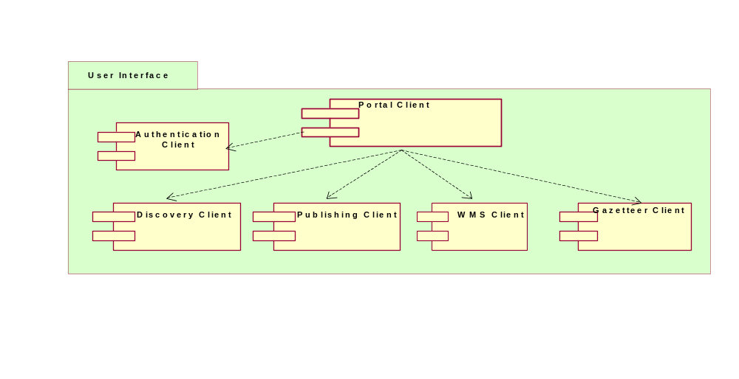
Figure 3.15: User Interface Package
Figure 3.16 shows the components, which are involved in harvesting information about data sources that are available to the Portal.

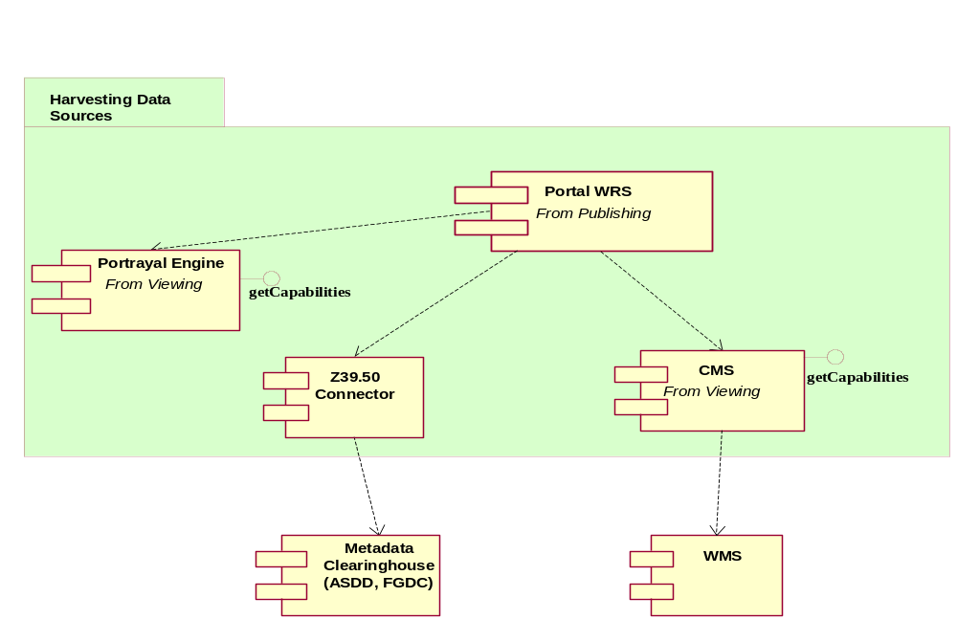
Figure 3.16: Harvesting Data Sources Package
SLIP defines several ways to populate its local registry, i.e., publishing:
- Use the publishing client. In this case users manually populate WRS, the web registry service, through the discovery client, as shown in Figure 3.16. The registry can go out periodically to those already registered resources and harvest their capabilities document and metadata documents.
- Harvest the capabilities and metadata documents of the WALIS Interragator and ASDD clearinghouse nodes through the Z39.50 connector.
- Harvest the capabilities document of Cascading Map Service (CMS).
- Harvest the capabilities document of the Portrayal Engine.
- The registry can also harvest metadata documents either directly from the NSDI clearinghouse or by following the URL that can be included in the capabilities document. This URL points to the location of the metadata XML document of the underlying resource. Alternatively, the harvesting can start from the metadata document and search for the OGC Link element in the metadata which points to the capabilities document.
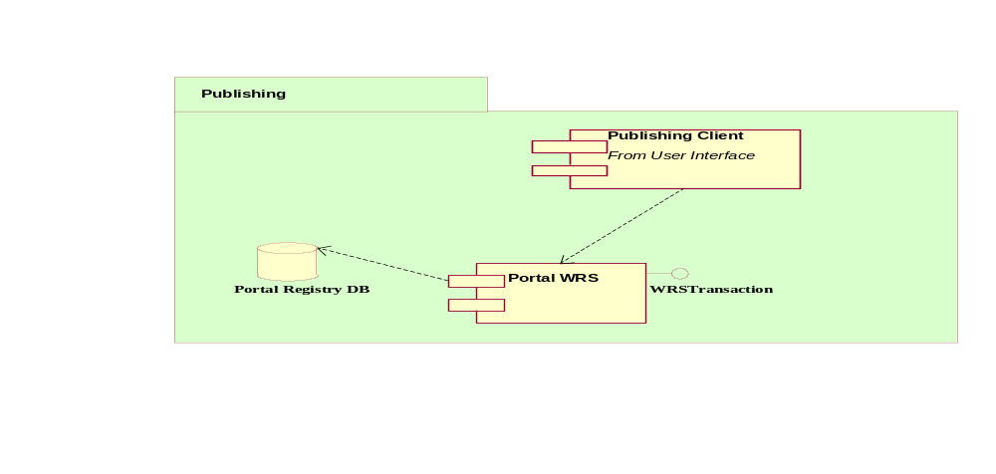
Figure 3.17: Publishing Package
Figure 3.18 shows the two alternatives to discover resources. The gazetteer client allows users to search the designated GNIS database through the Gazetteer connector. The discovery client search and display the metadata through the getRecord and the getResourceByID respectively.
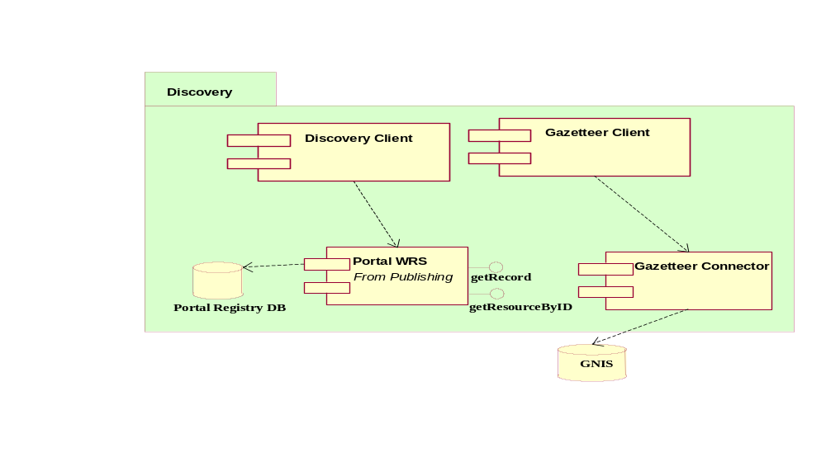
Figure 3.18: Discovery Package
Once the resources of interest are discovered the user launches the viewer client. It is expected that the registry records include the URL to the capabilities document of the discovered WMS resources. As shown in Figure 3.19, the viewer client uses the capabilities document to display information about the layers stored in each WMS resource. The viewer client can also invoke the Portrayal Engine. The portrayal Engine is a WMS, which allows clients to issues getMap requests with SLD and WFS parameters. Figure 3.19 also shows the SLDs are stored in a registry. The registry is also based on the OGC WRS specifications.
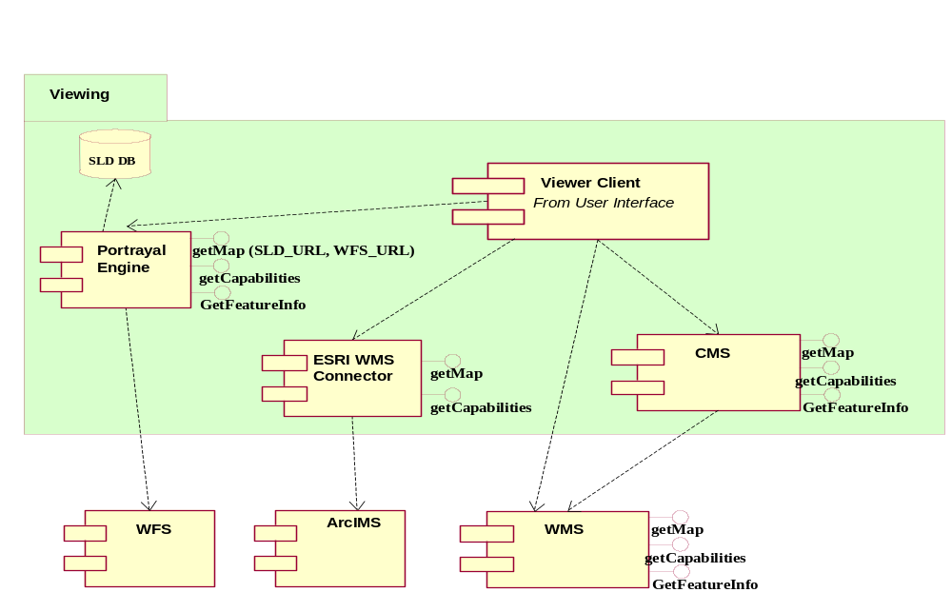
Figure 3.19: Viewing Package

User interactions mediated through SLIP
When a client user first invokes a SLIP Portal, the default state of the application is presented. This default state shall be the Viewer Client component. The Discovery, Gazetteer and Publisher Client interactions should be viewed as temporary tasks that return the user to the Viewer Client, possibly modifying the state of the Viewer Client based on the results of the interaction. The Portal is able to store the active context information of the user so that users can return back to Portal from where they left they last used it. This capability uses the OpenGIS WMS Context discussion paper.

Sample Use Case Summaries
Full elaboration of the SLIP engineering model will require comprehensive definition of use cases. That task is beyond the scope of a notional architecture but a number of summary samples are presented to illustrate the envisaged interactions and process flows amongst representative SLIP components, their interfaces and clients.

Publish
Publishing geodata-product, geodata-service or geodata-collection (optional with accessPolicy)
Name of use-case | Publish geodata-product without service accessibility
Actors | Geodata-publisher with ‘publish-authorization‘.
Description | This use-case describes the process of a geodata-publisher publishing a geodata-product or geodata-collection into a catalog. The data are accessible via a request, order, or download URL contained in the metadata, but are not visible through a WMS, WFS, or WCS. The metadata are located remote from the catalog.
Pre-conditions | - Publisher is authorized.  - Publisher has the right to write into the catalog.  - Geodata description includes content-metadata as XML (optional: access Policy-metadata - e.g. usergroups or roles which can modify/search).
Flow of events | - Client (publisher) logs into Catalogue-service.  - Client (publisher) submits URL of geodata description or of an externally Web-accessible directory of metadata or pushes the metadata to be catalogued.  - Catalogue acquires and extracts metadata.  - Catalogue validates geodata description which includes:  - Validation of metadata syntax and content  - Optional: validation of accessPolicy-metadata  - Catalogue responds to client on success or failure.
Post-conditions | - Metadata inserted into catalogue (if validated)
Remarks

Publishing a geodata-product linked to one or more services
Name of use-case | Publish geodata-product with service accessibility
Actors | Publisher with ‘publish-authorization‘.
Description | This use-case describes the process of publishing a geodata-product that is associated with an explicit (tightly-bound) OGC service: a WMS, WFS, or WCS. The metadata are located remote from the catalogue.
Pre-conditions | - Publisher is authorized.  - Publisher has the right to write into the catalogue.  - Content metadata is web-accessible in ISO 19115/FGDC XML format with embedded link to services invocation URLs (e.g. getMap, capabilities)  - Services metadata (capabilities) is web-accessible with embedded MetadataURL to one or more content metadata records
Flow of events | - Client (publisher) logs into Catalogue-service.  - Client (publisher) submits URL of content-metadata or a capabilities request to be catalogued.  - Catalogue acquires and extracts metadata.  - Catalogue validates geodata description which includes:  - Validation of metadata syntax and content  - Catalogue validates capabilities for WMS, WFS, or WCS  - Catalogue traverses links from content-metadata to associated service(s) and builds an association  - Data and service characteristics indexed for search.  - Catalogue responds to client on success or failure.
Post-conditions | - Metadata inserted into catalogue (if validated)
Remarks | While looking for content-service associations, the resource should be findable by content metadata of the service as well as by content metadata of the coupled-data.
Scenario:
A statewide transportation dataset is described using ISO 19115/FGDC metadata that is accessible via a linked OGC Web Map Service. WMS capabilities are established as the service is set up, including links to the data source descriptions (content-metadata) using WMS 1.1.0 Metadata URL conventions. Data Descriptions (content-metadata) likewise include references to related getMap, getCapabilities, and GetFeatureInfo requests as URLs qualified by their service and operation types.

Discovery and Viewing Interaction
A Discovery operation is initiated from, and ultimately returns to, the Viewer Client. The basic idea is that the user is looking at a map, wants to add some data, performs a search to select one or more datasets, and is returned to the map that has now been augmented with additional data. If the search yields only non-displayable data (no WMS or portrayal service), user should be returned to old map after disposing of discovered data as desired. Users of the Portal have ability to constrain search based on:
- Keywords
- Area of interest (including current map area as one choice, and option to choose a different area - may be linked to Gazetteer and/or a map-based selection widget).
- Availability of OGC WMS/WFS/WCS for data (i.e., search only for "Primary" and "Secondary" data; User can explicitly broaden search to "Tertiary" sources if desired).
- Time period and other appropriate metadata parameters.
In general, users do not have to explicitly choose what nodes to search, as is currently the case in the AASD interface. Users instead search the local registry, which updates itself by periodically harvesting the metadata of the resources.
The discovery interaction sequence includes:
- User is viewing map in Viewer Client component.
- User selects Search button to invoke Discovery Client component.
- User is presented with a form including widgets in which to type or choose from search terms, checkbox (on by default) to use current map area, checkbox (on by default) to limit search to data that can be displayed in the Portal, widgets for other appropriate metadata parameters.
- User fills out and submits form.
- The query is submitted to the Portal WRS
- Discovery CG displays results for user. Results include basic metadata (e.g., title, source, catalogue node where found, etc.) and link to retrieve full metadata for each record. The returned set also includes a URL to the capabilities document of the available resources.
- User is returned to Viewer CG with updated map.
- User may not be satisfied and returns to Step 3 with values pre-filled for modification and new search.

Discovery by Placename
This use case allows users to change extent of map based on geographic place selection. A Gazetteer operation is initiated from, and ultimately returns to, the Viewer. The basic idea is that the user is looking at a map, wants to navigate to a new location based on place name, performs a gazetteer search that determines an appropriate bounding box, and is returned to new map that shows a new location and (to the extent possible) the same data. If active data source(s) are not relevant to the region of interest, user should be notified and offered to delete the source(s). If the gazetteer search fails (e.g., place name not known), user should be returned to old map. Multi-step search process should either (1) allow User to click browser's Back button and return to old map or (2) always have button/link that in effect cancels search and returns user to old map.
Interaction sequence of the Gazetteer service include:
- User is viewing map in Viewer CG component.
- User selects Place Name Search button to invoke Gazetteer CG component.
- User is presented with form to type in desired place name, and possibly to select other attributes to narrow search (e.g., feature type, or US state if US gazetteer).

Name of use-case | Navigate to location
Actors | User with ‘display-authorization‘.
Description | This use-case describes the process of a user defining an area of interest based on navigation through a hierarchy or list of named places that are served by an OGC gazetteer (WFS-G).
Pre-conditions | - One or more gazetteer services are established that support the Gazetteer Profile of the WFS for a given placename scheme.
Flow of events | - User is provided a button with suitable icon to activate a gazetteer function.  - One (or more) placename hierarchies are presented to the user to help navigate to a location of interest.  - User selects one placename scheme.  - Search/request of gazetteer is made to return features and their geometries.  - Interface presents a highest-order list of suitable places as GML.  - User selects a place of interest, client stores the bounding box.  - Interface presents the option to use this place or present the next lower level of a hierarchy, if present.
Post-conditions | - Selected place is used to constrain a request bounding box and the map is rendered for that bounding box.
Scenario:
User is interested in navigating to a place of interest and seeing what data and maps are available there. They open the gazetteer widget and are presented with one or more gazetteer types (e.g. political subdivisions, river basins, postal codes). The user selects political subdivisions and is presented a pick list of alphabetically sorted countries. The user selects a region and is then presented with a pick list of next-level subdivisions (shires). The user is then presented with an option to select shires or localities. At any decision point, the user could request the map to be adjusted to the area of interest or to continue to traverse the hierarchy. In some systems, as a placename is selected, the map extent could be automatically refreshed to show the new area of view.

Other Use Cases
As noted earlier, a complete elaboration of the SLIP engineering model will require these summary use cases to be developed in more detail, and the elaboration of many other use cases including:
- Harvesting from National SDIs and Other Data Sources
- Coordinate Transformation And Map Display Invoking the Map Portrayal Engine

Technology Viewpoint
This section focuses on specification of technologies to be implemented to realize the notional SLIP architecture as an operational system.
A detailed technical engineering specification is beyond the scope of a notional architecture, and will require site-specific information to be gathered at a later date. However, a discussion of the engineering supporting a hypothetical registry portal service makes it possible to demonstrate the nature of technologies and related standards to be considered.
provides a representative technology view based on current commercial and open-source offerings, to be further elaborated during the SLIP design process. Specific technologies (e.g. ‘Oracle 8.17’, ‘Tomcat 1.4.1_02’) are indicative rather than proscriptive.
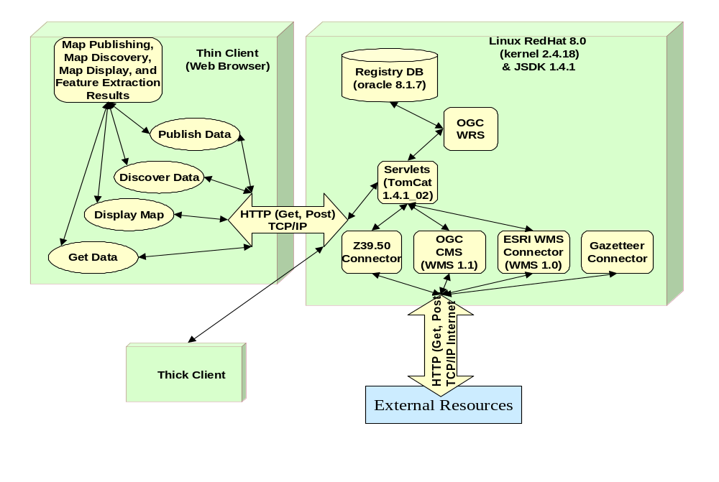
Figure STYLEREF 1 \s 3. SEQ Figure \* ARABIC \s 1 13: SLIP Portal Technology Viewpoint
The Portal package indicated need not represent a single physical system located, or under the control of, any particular institution. The configuration selected for SLIP will reflect the collaborators’ requirements for reliability and cost-effectiveness rather than constraints of the standards underlying SLIP.
A Portal’s thin client can run on any standard web browser. A Portal is based on standard HTTP protocol operations, GET and POST, and does not require any additional software to be installed on the end-user machine. A Portal uses the following baseline specifications:
Web Map Service (WMS). OGC Web Map Service Implementation Specification, version 1.1.1.
Geography Markup Language (GML) v2.1.2. OGC Specification.
Filter Specification OGC Filter Encoding Implementation Specification, version 1.0.
Styled Layer Descriptor (SLD) Specification OGC Styled Layer Descriptor Implementation Specification, version 1.0
Web Coverage Service (WCS) OGC Discussion Paper, version 0.0 (RFC-15): Web Coverage Service,
WMS Context XML. OGC Web Map Context Documents, version 0.1.7 (OGC RFC-16, 03-036)
Gazetteer Service. OGC Gazetteer Service Profile of the Web Feature Service Implementation Specification, version 0.9 (OGC Discussion Paper #02-076r3)
Web Registry Service. OGC Web Registry Service (Interoperability Program Report #03-024)
FGDC Content Standard for Digital Geospatial Metadata (CSDGM), version 2,

Institutional Issues Arising from the Recommendations

Outline implementation sequence for SLIP
Table 4-1: Incremental SLIP Implementation Outline (following) suggests a phased implementation programme building on core capabilities in an incremental manner. Immediate progress can be made in implementing SLIP, namely designating the custodians for the core operations of the Services Registry and the Gazetteer Names services. SLIP will, in a sense, come into existence the days that both these services are declared operational. Additionally, existing services such as WALIS Interragator metadata catalogue, the WA atlas and the WALIS OGC demo can be presented (at least as an interim measure; the mission for these applications is somewhat limited). The mechanisms for process accounting can also be established early on, to provide experience and procedures for usage monitoring, service availability audit and capacity planning, even though the need for full-up financial accounting will take longer to be met.
Table 4-1: Incremental SLIP Implementation Outline
Phase | Priority | When | Capability
Core Element Kickoff | Highest | Immediate | SLIP Services Registry under a recognized custodian
Core Element Kickoff | Highest | Immediate | SLIP Gazetteer Name service (ex GEONOMA) as WFS
Core Element Kickoff | Highest | Immediate | Map Viewer, Gazetteer, Publisher and Discovery client generators
Core Element Kickoff | Highest | Immediate | WALIS OGC demo atlas interfaced to SLIP
Core Element Kickoff | Highest | Immediate | WALIS Interragator data catalogue interfaced to SLIP
Core Element Kickoff | Highest | Immediate | Process accounting for usage monitoring, capacity planning data etc.
Buildup | Important | To kick-off + 12 months | Designated WALIS legacy systems (esp. WMS) have OpenGIS interfaces
Buildup | Important | To kick-off + 12 months | Distributed data catalogues for WA custodians
Buildup | Important | To kick-off + 12 months | One or more services from outside WA (e.g. Geolinking Service from Canadian Geoconnections) interfaced to SLIP
Buildup | Important | To kick-off + 12 months | One or more showcase applications inherently dependant on functional and reliable interoperation amongst WALIS collaborators and partners; these need not be merely mapping functions
Buildup | Important | To kick-off + 12 months | User registration and access control
Buildup | Important | To kick-off + 12 months | Interoperation with global metadata catalogue services (AASD; FGDC Clearinghouse Network; International Directory Network/ Global Change Master Directory?)
Buildup | Important | To kick-off + 12 months | Data delivery through WFS
Buildup | Important | To kick-off + 12 months | WFS-based data editing and recommitment to WALIS databases
Buildup | Important | To kick-off + 12 months | User financial accounting and chargeback
Consolidation | Medium | To kick-off + 24 months | Selected operational services implemented
Consolidation | Medium | To kick-off + 24 months | Additional joined-up services
Consolidation | Medium | To kick-off + 24 months | Demonstrated audit and management services with remote partners (Geosciences Australia? USGS? UK Ordnance Survey?
Consolidation | Medium | To kick-off + 24 months | Demonstrated interoperation with emerging grid applications, including audit and management functions
Evolution | Optional | On-going | Emerging OpenGIS specified such as Web Coverage Services
Evolution | Optional | On-going | Operational audit and management services with remote partners (Geosciences Australia? USGS? UK Ordnance Survey?
Evolution | Optional | On-going | Interoperation with emerging grid applications, including audit and management functions
Figure 4.20: Notional SLIP Component Implementation Sequence and Capability Dependencies (following, over 2 pages) suggests a plausible roll-out sequence for SLIP capabilities.
A consolidation period can follow, during which WALIS collaborators (and possibly commercial and community custodians) implement where necessary the OpenGIS specified interfaces to existing map, image and geo-data services, and announce these to SLIP Services Registry. This is also a period when WALIS (and other) custodians may elect to operate and manage their metadata catalogues autonomously, to complement the existing Interragator. New business services, exploiting the newfound interoperability, may be designed and implemented – for example, integrating location name selection with ordering of satellite and aerial photo image data.
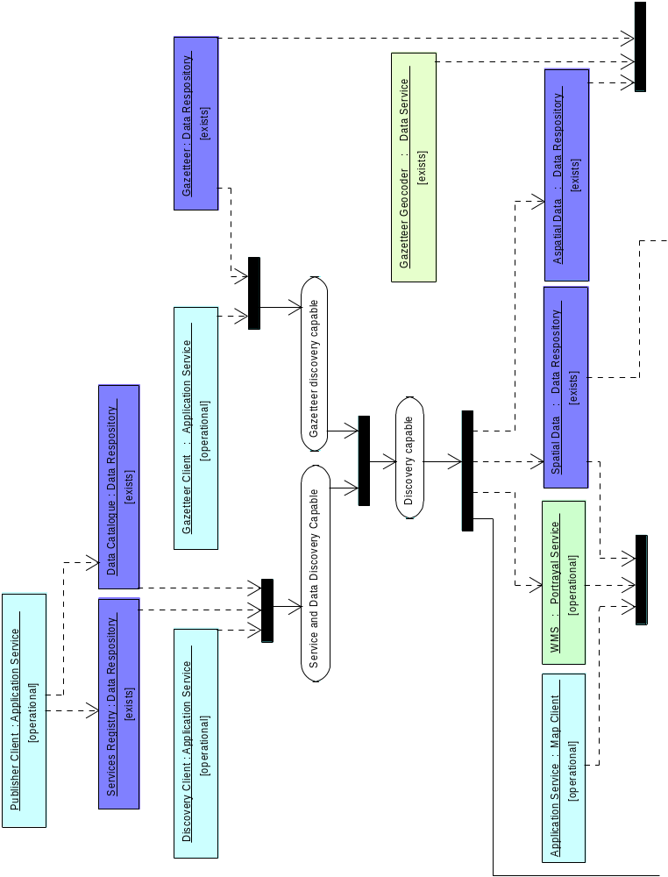
Figure 4.20: Notional SLIP Component Implementation Sequence and Capability Dependencies
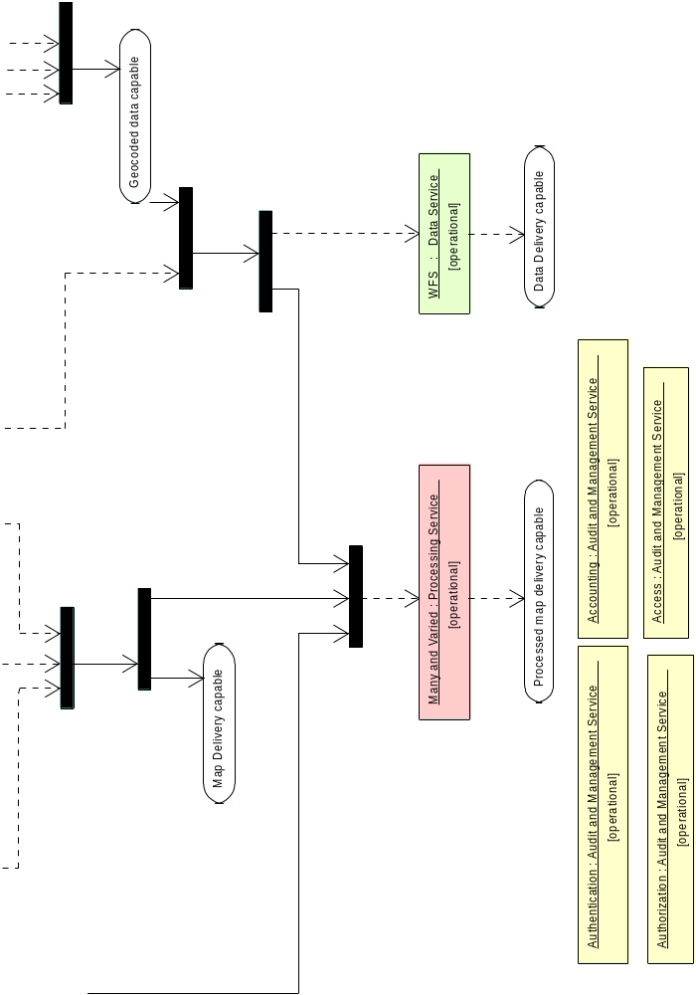 Fig 4.1 (cont.) Notional SLIP Component Implementation Sequence and Capability Dependencies

New service opportunities
Implementation of SLIP will, even during initial stages, present opportunities for implementation of novel services nor previously realized. A thorough-going elaboration of these is beyond the scope of this report but ‘quick wins’ that come to mind include:
- embedding common location-name selection for existing product lines such as maps and imagery i.e. users able to specify ‘Warragul’ or ‘the Exmouth Gulf’ as their point of interest rather than being constrained to use geographic coordinates, bounding boxes or scene ID numbers
- returning aggregated search results across many service ‘types’ originating with many custodians e.g. maps, data sets, land claims, community interests etc.
- seamless integration in SLIP services of WA-related data originating from SDI custodians elsewhere in Australia
- seamless integration in SLIP services of WA-related data originating from SDI custodians elsewhere in the world

Governance Issues, Policy, Dependencies and High Level Requirements: functional elements required for the SLIP
SLIP is intended as a service integrator. Exposure of aggregated services will introduce the requirement for a number of decisions regarding policy and practice that have not been confronted with individual agencies. These are institutional matters strictly beyond the scope of the current technical report. Yet, they will colour the overall effectiveness and success of SLIP and so are worth raising briefly for DLI’s consideration.

Dependencies and service exchange agreements
Services may be potentially incorporated from any provider, anywhere in the world, who exposes their services through OpenGIS-compliant interfaces, with little or no control by SLIP collaborators over issues such as service availability, reliability, integrity or security. SLIP’s acceptance by users as a reliable and effective system will be dependant on factors outside the control of the WALIS collaborators.
In instances where a reputable remote custodian is providing a high-value service, it will be desirable or necessary to secure formal or semi-formal quality of service agreements, perhaps as parts of memoranda of agreement or commercial services contracts. This is not a standards or specifications issue but nonetheless crucial to reliable, quality-assured service integration through SLIP.

Managing knowledge of services and their characteristics – The SLIP Registry of Services
The SLIP Services Registry will be the backbone of the system. As noted earlier, its custodian will be required to ensure the highest level of availability, reliability, integrity and security

Managing knowledge of custodians and service providers – an Institutional Registry
A SLIP registry of institutional authorities, responsibilities and policies will provide a useful reference facility, for example, in the simplified application of institutional cost recovery and data access policies for all staff and services, rather than these needing to specify these factors for each individual user, data set or service. The WALIS collaborators will need to identify or designate a custodian for the institutional repository.

Managing knowledge of users and their characteristics – a Customer Registry
SLIP is required to support distributed services amongst autonomous, authoritative custodians. SLIP is also required to support user authentication (“Is this user who they say they are?”), user authorization (“I recognize this user but are they qualified to exploit services?”), user access control (“I recognize the user as qualified but what particular services are they allowed to use in what ways?”) and user accounting (“How much of the service has this user actually used, and at what cost?”).
A choice will be required between implementing user audit and management functions in either centralized and distributed ways. The former is obviously simpler and more familiar to system administrators. However, it suffers from two major deficits:
- The single WALIS collaborator taking on the role unique of user information custodian within SLIP will confront an open-ended task of scaling up user accounting as new services join SLIP and new sources of monitoring data have to be integrated with the accounting processes; will have to implement changing policies originating other than the custodian and yet for which the custodian will be responsible for realization; and will be administering policy and finance instruments originating anywhere on earth and for which the custodian may lack the necessary international mechanisms.
- It represents a barrier to SLIP goal of the increased value of WA land Information through increased uptake. Users originating in other systems such as state SDIs and NSDIs will need to become familiar with SLIP administrative requirements and procedures before being able to realize value from services, despite the fact that they are recognized and accounted users in their own systems. And this user may have already had to establish accounts in numerous other systems.
SLIP may implement distributed user audit and management administration whereby a user registers only once at their home institution or at a single portal
Distributed user audit and management administration may be a more difficult technical implementation but has the advantages of:
- Retaining user information custodianship with the institution of association and for which administrative authority exists and mechanisms such as account billing are already implemented;
- Opening the SLIP users to access services elsewhere in the world without having to establish new authorities, implement new instruments, or having to navigate a new administration.
It is strongly recommended that the SLIP community adopt distributed user audit and management in principle immediately, and SLIP implement this in practice as soon as an acceptable technology can be agreed upon.

Managing service level agreements, including for metadata services – an Interaction Registry,
With or without distributed user audit and management, SLIP will only succeed by reducing the costs of data and services replication, thus exposing WALIS collaborators to issues of inter-institutional reliability. Administrators are discomforted by the prospect of relying on core, mission-critical functions that are outside their control. This concern can be exacerbated by considering the shaky condition of much of the Internet backbone upon which SLIP will be implemented. The fact that Institution X cannot process planning permissions because Institution Y’s land information is blocked by a denial of service attack is no consolation to Institution X’s paying clients.
The approach recommended here is the same as has been adopted in other business areas i.e. to treat it as an outsourcing arrangement subject to contractual conditions (including penalties) and assessed according to agreed statements of the Quality of Service. Institutions providing valued and demanded services focus management and technical resources on the securing the operational reliability of their own core services, and demand that their peers do the same. Resources for system operations that are currently diluted in attempts to replicate other institutions’ data and services are brought to focus on mandated core functions. Rather than an agricultural institution investing staff effort and money in developing and operating a needed geo-reprojection service, let there be one reprojection service, operated by the institution most motivated and competent to provide and maintain it, and let the agricultural institution focus on agricultural services.

Managing knowledge of data elements and their characteristics
Each institution participating in SLIP, whether government department or collaborator, will need to consider carefully the most desirable and pragmatic manner for exposing the application of its user access policy in this open environment, especially when it is recalled that the ‘user’ my in fact be a remote process rather than an individual person. Wide-reaching user access policy expectations such as ‘All users of DLI services must be registered in the DLI customer management system’ need to be considered against the optimal requirements for service utilization, revenue, security and integrity. Such considerations are beyond the scope of this paper but are summarized as indicative of convergent initiatives with which SLIP will be required to interact as the business processes that it is required to support diversifies.

Spatially related data services
The purpose of all interoperability efforts is to make data accessible, as appropriate, and to get information to flow within defined business processes, to deliver answers. The notional architecture sets the context for the removal of barriers in a pragmatic, phased and sustainable manner. Spatial data, accessible through well known standard interfaces meeting open specifications creates opportunities for spatially related data services to be utilized by causal users (not-expert in spatial information) and for the data to be incorporated into the information infrastructure without the requirement to commission dedicated systems. The constraints and caveats described in this section of the report demonstrate the feasibility, even at the current state of open platform computing, to define extensible administrative and operational policies for spatial and related services to be delivered over a medium with ubiquitous access (the Internet) through general purpose software (the browser).

e-authentication services
The SLIP notional architecture is not limited to web-based interoperability but, as per the current standard specifications, the primary means of access will be via HTTP. The basic operations of requesting, displaying and querying data have considerations of, is this user or process authorized to have access and can the information be displayed on or by the requesting device? Authentication mechanisms are established to recognize the user (Customer Registry) and once recognized to constrain the activities and data sources that are visible and/or accessible by ascertaining the level of authorization or permissions granted to the user. Once the context for the interaction has been established the communications are assured and secured through, for example, Secure Sockets Layer (SSL) with Public Key Infrastructure (PKI) being used for generating and exchanging X.509 certificates for client and server authentication. Such security issues will need to be addressed from:
- e-authentication common services; to
- single sign-on and authorization services; to
- access control by requestor application and transaction services; to
- encryption of network communication to the browser; to
- logging of intra/inter enterprise integration messages and legacy system updates; to
- firewalls that protect the physical environment
Authentication and authorization services are essential basic requirements for auditing transactions and other services such as pricing, invoicing and settlement. The financial standing of the requestor is an essential component for security and integrity.
SLIP will need to develop its authentication and authorization policies in line with national and international initiatives. The origins of a request may well invoke a filtering suite of permissions (constraints) depending on whether the origin is inter-organisational or inter-national, to the level of charging GST.

e-business services
Departmental services interoperability interfaces will need to support a range of traditional business services. The notional architecture supports the model that such services will be accessible from their respective domains of expertise. Indicative efforts are underway between OGC and OASIS to harmonise addressing between the requirements of customer information systems and those of land information. The impetus is coming from homeland security, cross-border issues, taxation, immigration and naturalization, and drug enforcement.
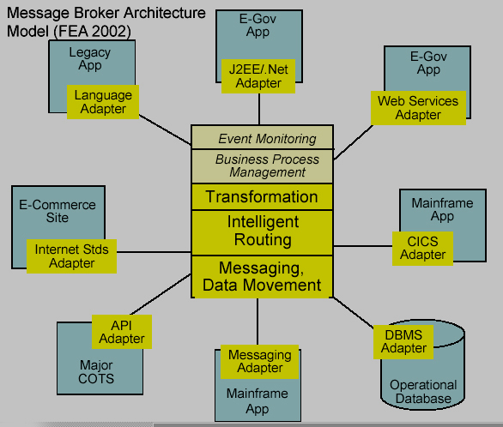
SLIP will be delivering services according to a number of different trading models. These will include government-to-government, government to the public, government to business and business to government. Each model has different trading parameters, licensing and pricing constraints. Some of the most demanding applications are in the domain of public health where privacy of customer information and records of interaction with on-line systems are most sensitive. OGC, OMG, OASIS and the OpenGroup are collaborating in convergence of standards and specifications to address business process definition and interoperability for chaining services, which work across traditional domains where the legislated requirements for probity vary. The SLIP interfaces and models for notification have been developed to accommodate such anticipated requirements. Within the context of a message broker architecture which provides the reference framework for the creation of business process workflows and the just-in-time manufacturing of responses to requests of heterogonous data repositories. The XML based web services models represent the current state-of-design in e-government, as illustrated in Figure 4.22 below.
Figure 4.21: Message Broker Architecture
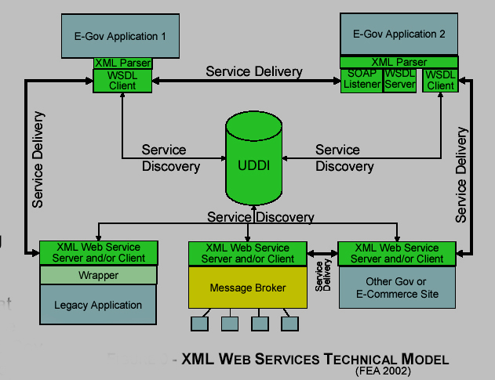
By viewing spatial data and processing services as part of business processes, the architecture aligns with that being developed for the delivery of interoperable e-government services in general.
Figure 4.22: XML Web Services Technical Model in e-government

e-government services
SLIP will become a component in the evolving e-government framework. Geographic, location based, information is a critical data type. The European Commission released its working paper “Linking up Europe: the importance of interoperability for e-government services” in July 2003 with the recognition of the requirement to ”re-organise administrative processes to support the seamless delivery of e-government services”. The need to have a consistent interface for the delivery of information products and services, while administrative and other services re-organise will be essential. The just-in-time access to data and creation of information products requires open architectures of interoperating components while protecting private (to the organization) business process specific activities.
The contexts that have been acknowledged in the development of the notional architecture include the US Federal Enterprise Architecture in which the e-government interoperability model is encapsulated as shown below in Figure 4.23: E-Government Interoperability Model.
Example implementations are being delivered and others planned in Europe and the US which are illustrative of the benefits that governments and their customers are expecting from the technology. Recent examples from the US include:
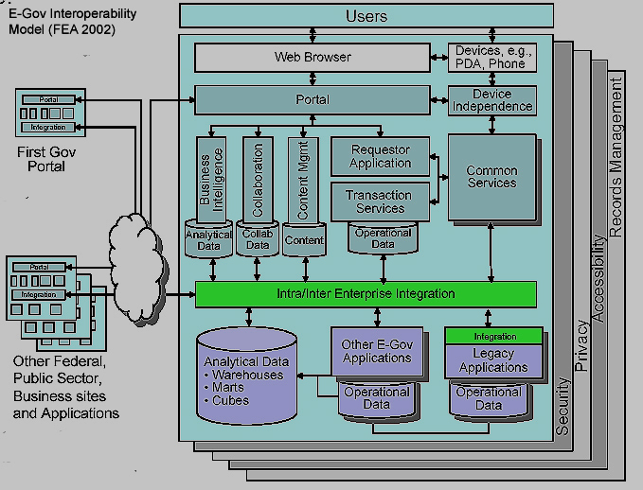
"The planned project will enable sharing of critical infrastructure, key asset data, supporting response data layers and information across governmental jurisdictions through a Bay Area Regional Homeland Security Data Server, the BAR-HSDS. This system will complement national and local homeland security and first responder initiatives. The goal is to design, develop, and demonstrate an operational prototype for the San Francisco Bay Area. The pilot system will facilitate critical infrastructure and key asset data information sharing, analysis, and high-level incident reporting in a heterogeneous environment. The desire is to build a regional system that is affordable, easy to use, and secure.
The BAR-GC is a regional GIS coordination and data sharing organization comprised of municipal, county, regional and state government representatives with jurisdiction in the nine-county San Francisco Bay Area - an area over 7,000 square miles with a population more than 6 million people. The BAR-GC also includes non-profit, utility, educational and private sector GIS professionals. It is chartered to "Function as a regional body for the San Francisco Bay Area, to review the California GIS Council's reports, provide recommendations on policy alignment with local and regional needs, and be a focal point for partnerships to build California's geographic information infrastructure."
Figure 4.23: E-Government Interoperability Model
The concept for Texas is that:
"The planned project will help develop a standards-based Texas Critical Infrastructure System (TCIS), a key portal in the emerging national capability, which will produce and enable sharing of the Critical Infrastructure-Key Asset Layers of the National Map of Texas, through a common portal, across state, local, federal and tribal systems. A key objective of this project is to implement the Geospatial Interoperability Framework (GIF), which is based upon information and service standards and specifications (ISO, ANSI, and FGDC standards and OGC specifications). This framework enables cross-organizational sharing of TCIS and related NMP and HSIP resources.
“TCIS will complement national and local homeland security initiatives to minimize the risk of terrorism and maximize an effective response to acts of terrorism. The goal is to design and develop an Initial Operating Capability for the State of Texas that enables critical infrastructure and key asset data and information production, sharing and analysis in a
distributed, heterogeneous environment. This system will fully leverage and refine the results of national efforts like the NMP and HSIP, and also leverage existing State GIS assets to the fullest extent. TCIS will enable state, local, tribal and private institutions with GIS capabilities to publish, discover, access, exchange, and maintain this geospatial information, as well as share this information and the associated geoprocessing services with emergency management and public safety agencies to support critical infrastructure planning, protection, response, and recovery operations."
OGC Members have requested that a Real Land and Property Initiative be outlined and proposed for sponsorship to the Members which recognizes that:
“Property and land information databases are an important resource that is essential to many activities such as managing property ownership, development, tax assessment, and government service provision. Property and land information are also vital to a range of other complimentary government, business and consumer services such as emergency response and recovery, real estate transactions, land planning, flood mapping, and risk assessment.”
The goals for the initiative are described as:
“The ultimate goal of the OGC Property and Land Information Initiative is to promote increased understanding of the application of OpenGIS® Specifications to the challenge of cross-organizational and cross jurisdictional access to critical information. The Initiative would seek to design, test and operationally validate open architectural frameworks for distributed property and land information networks. As part of the growing "Spatial Web", these networks will allow information to be easily exchanged between consumers, governments, and businesses for many different purposes. This information would be accessible online through OpenGIS Interface Specifications and other standards consistent with best practices defined as part of National and Global Spatial Data Infrastructures and E-Government initiatives. This initiative will demonstrate how standards-based distributed networks of databases and information services can help consumers and citizens to access vital data, businesses to offer premium customer services, and governments to provide more effective service to citizens.”
DLI and the other WALIS participants, through considering a notional architecture for SLIP, are defining issues and stating requirements which are very much in line (if not to the forefront) with those being asked by equivalent organizations across the OECD and in the developing world.

Conclusions in relation to the institutional issues and context for SLIP.
The notional architecture proposed draws together current thinking and experience in providing a pathway for the migration of complex heterogonous data and operating environments into a secure but rationalized environment to support the requirements of government, business and the public for timely access to data of known provenance and fit-for-purpose. Data will require re-casting and other forms of processing to deliver answers to other computer based applications and/or end users. The vision of accessing appropriate data and processing resources on an as-needed basis is to be realized, in part, by SLIP. SLIP is not an island of e-government, it is indicative of the issues to be faced (mainly institutional) and the ability of the policy makers, planners, designers, technologist, domain specialists and users to interoperate and move from being creators of data with limited distribution to specialist audiences to creating information products and services relevant to local, regional and global communities.

Conclusion: Implementing the SLIP strategic framework.
SLIP is to provide a new level of services to the WA Real Property and Land special interest groups as well as the public at large. SLIP is to serve professional and casual users with equal facility using the ubiquitous communications infrastructure of the Internet and a universal user access mechanism, a standard web browser.
SLIP is based on the common sense principal that “users have questions and want answers” – the answers must be affordable, correct and delivered quickly.
SLIP represents the Department of Land Information and its sister agencies’ commitment to “joined up government” by releasing a platform for asset realisation, education, innovation, market development, public participation and research and development.
SLIP is positioned as a “superstructure” to hide the complexities of departmental operational information creation and management systems from casual users, whether working within government or outside.
SLIP is an automated information production line that will take inquiries from a user, use its directories to find the information required, supervises reprocessing the raw information and manages delivery of the answer. SLIP will also monitor production costs for metering and, as appropriate, billing.
SLIP’s success depends on the use of international standards, supported by governments, industry and technology vendors, to enable an open dialogue between data and processing assets for the delivery of answers, and receive customer feedback.
SLIP respects the security of the data and process suppliers with associated custodial responsibilities.
The following are the key recommendations. These recommendations are based on the OGC team’s understanding of the requirements of DLI as well as experience gained from similar projects.
- A commitment be made for SLIP to be created within an open, distributed, standards based computing architecture with a phased implementation.
The phased implementation plan would include:
- Putting in place ASAP a systematic approach to appropriate metadata capture and storage in a compliant metadata catalogue.
- The SLIP services registry be designed and implemented ASAP.
- WALIS collaborators committing to implementing SLIP as soon as a host for the SLIP registry is identified and make the portal available to WALIS participants.
- Individual WALIS agencies, or suitable commercial or community providers, implementing other SLIP core functions such as a gazetteer name service.
- A programme to schedule the incremental expansion of SLIP services, including services provided by WALIS custodians as well as appropriate services operating interstate or overseas in other SDIs.
- A programme for incremental development of user audit and management services to phase SLIP through provision of unregistered free-to-air services (with accounting for utilization), user registration, user registration plus access control, to user cost accounting, and that exchanges be undertaken with partners operating user management services, such as GeoScience Australia
- WALIS agencies scheduling implementation of the necessary OpenGIS interface elements over their current land information services to make them interoperable.
- SLIP being opened to broader usage as a platform for commercial, community and civil groups.

Bibliography
[1] ISO 10746, Information technology -- Open Distributed Processing -- Reference model, see http://www.iso.ch/iso/en/ittf/PubliclyAvailableStandards/c020696e.zip for overview
[2] ISO/PDTR 19103, Geographic Information – Conceptual Schema Language, see http://www.isotc211.org/pow.htm for a brief description.
[3] ISO/CD 19107.3, Geographic Information - Spatial Schema, see http://www.isotc211.org/pow.htm for a brief description.
[4] ISO 19108, Geographic Information - Temporal Schema, see http://www.isotc211.org/pow.htm for a brief description.
[5] ISO/DIS 19109, Geographic Information – Rules for Application Schema, see http://www.isotc211.org/pow.htm for a brief description.
[6] ISO 19118, Geographic Information – Encoding, see http://www.isotc211.org/pow.htm for a brief description.
[7] ISO/CD 19119 (ISO TC 211 N 1044, 2001-01-29) Geographic Information – Services, see http://www.isotc211.org/pow.htm for a brief description.
[8] ISO/CD 19115 (ISO TC 211 N 1024, 2001-01-30) Geographic Information – Metadata, see http://www.isotc211.org/pow.htm for a brief description.
[9] ISO 23950 Information Retrieval (Z39.50): Application Service Definition and Protocol Specification, see http://lcweb.loc.gov/z3950/agency/document.html
[10] FGDC-STD-001-1988, Content Standard for Digital Geospatial Metadata (version 2), US Federal Geographic Data Committee, http://www.fgdc.org/metadata/contstan.html
[11] OASIS ebXML see http://www.ebxml.org/
[12] OASIS ebXML Registry Information Model v2.0 available at http://www.oasis-open.org/committees/regrep/documents/2.0/specs/ebrim.pdf
[13] OASIS Public Key Infrastructure development, see http://www.pkiforum.org
[14] OASIS SAML v1.0 specification set available at http://www.oasis-open.org/committees/download.php/2290/oasis-sstc-saml-1.0.zip
[15] OASIS Universal Discovery Description and Integration see http://www.uddi.org/
[16] OGC Reference Model (ORM), available at: http://www.opengis.org/info/orm/
[17] OGC AS 1, The OpenGIS Abstract Specification Topic 5: OpenGIS Feature Geometry (ISO 19107 Spatial Schema), available at: http://www.opengis.org/techno/abstract.htm
[18] OGC AS 2, The OpenGIS Abstract Specification Topic 2: Spatial Reference Systems, available at: http://www.opengis.org/techno/abstract.htm
[19] OGC AS 5, The OpenGIS Abstract Specification Topic 5: OpenGIS Feature, available at: http://www.opengis.org/techno/abstract.htm
[20] OGC AS 12, The OpenGIS Abstract Specification Topic 12: OpenGIS Service Architecture, available at: http://www.opengis.org/techno/abstract.htm
[21] OpenGIS Simple Feature Specification for CORBA, version 1.0, available at: http://www.opengis.org/techno/implementation.htm
[22] OpenGIS Simple Feature Specification for COM, version 1.1, available at: http://www.opengis.org/techno/implementation.htm
[23] OpenGIS Simple Feature Specification for SQL, version 1.0, available at: http://www.opengis.org/techno/implementation.htm
[24] OpenGIS Catalog Services Implementation Specification, version 1.1.1, available at: http://www.opengis.org/techno/implementation.htm
[25] OpenGIS Web Mapping Server (WMS) Implementation Specification, version 1.1.1, available at: http://www.opengis.org/techno/implementation.htm
[26] OpenGIS Styled Layer Descriptor (SLD) Implementation Specification, version 1.0, available at: http://www.opengis.org/techno/implementation.htm
[27] OpenGIS Web Feature Server (WFS) Implementation Specification, version 1.0, available at: http://www.opengis.org/techno/implementation.htm
[28] OpenGIS Filter Encoding Implementation Specification, version 1.0, available at: http://www.opengis.org/techno/implementation.htm
[29] OpenGIS Coordinate Transformation Services Implementation Specification, version 1.0, available at: http://www.opengis.org/techno/implementation.htm
[30] OpenGIS Geography Markup Language (GML) Implementation Specification, version 3.0, available at: http://www.opengis.org/techno/implementation.htm
[31] OpenGIS Web Coverage Server (WCS) Request for Comment, OGC document 02-024r1. Available at: http://www.opengis.org/techno/requests.htm
[32] OpenGIS Web Services Architecture Discussion Paper, OGC document 03-025. Available at: http://www.opengis.org/info/discussion.htm
[33] OpenGIS Service Information Model (SIM) Discussion Paper, OGC document 03-026. Available at: http://www.opengis.org/info/discussion.htm
[34] OpenGIS Web Registry Service (WRS) Interoperability Program Report, OGC document 03-024. Available at: http://member.opengis.org/tc/archive/arch03.htm
[35] OpenGIS Style Management Services Discussion Paper, OGC document 03-031. Available at: http://www.opengis.org/info/discussion.htm
[36] OpenGIS Web Pricing & Ordering Service (WPOS) Discussion Paper, OGC document 02-0391r. Available at: http://www.opengis.org/info/discussion.htm
[37] OpenLDAP Foundation, see http://www.openldap.org/
[38] World Wide Web Consortium Extensible Markup Language (XML) 1.0 available at http://www.w3.org/XML/Core/#Publications
[39] World Wide Web Consortium Simple Object Access Protocol (SOAP) 1.1 available at http://www.w3.org/TR/SOAP/
[40] World Wide Web Consortium Web Services Description Language (WSDL) 1.1 available at http://www.w3.org/TR/2001/NOTE-wsdl-20010315

Appendices

Appendix 1: ISO/IEC 10746 overview
The ISO Reference Model for Open Distributed Processing (RM-ODP) (ISO/IEC 10746), the framework adopted by the OGC for specifying its reference architectures in the OGC Reference Model.
The framework specifies for four non-overlapping viewpoints se viewpoints are: Enterprise; Information; Computational; and Engineering viewpoints.
This collection of interrelated viewpoints will provide for the development of the CICE as an initiative that supports multiple technology goals within a business / mission-based structure. It will also provide a way of ensuring that that the elements of the CICE become incorporated into the OGC Reference Model, Federal / National Reference Models and other appropriate models, so that specifications based reusable elements can be adopted for common use, not only within the Critical Infrastructure Community, but also within the entire geospatial information community. CICE will be a source of new business needs, specifications requirements, initiative and specifications for the ORM. These additions to the ORM will be incorporated through established OGC procedures for updating and maintaining the ORM.
- The enterprise viewpoint is concerned with the purpose and scope of open distributed processing and how it relates to the overall business areas of responsibility and the service specifications. It also covers the primary roles and interactions required to use interoperable geospatial information and technology in a dynamic, distributed, information-sharing environment. The Enterprise Viewpoint has focused on lines of business and business needs, whether in government, private or civil sector.
- The information viewpoint focuses on the information and associated processing of a system, using schemata to specify the way that information may be transformed.
- Computational viewpoint decomposes the function of a system into objects that interact at interfaces, which in turn provide natural lines along which a system may be partitioned for distribution.
- The engineering viewpoint is concerned primarily with the interaction between distinct computational objects: its chief concerns are communication; computing systems; software processes; and the clustering of computational functions at physical nodes of a communications network. It also provides terms for assessing the “transparency” of a system of networked components – that is, how well each piece works without detailed knowledge of the computational infrastructure.

Conformance
Assessing conformance requires consistency across the various viewpoints (i.e. clear mappings of concepts) and across the models they define. In general, the set of viewpoint specifications should not make mutually contradictory statements. Furthermore, each specification should include correspondence statements that relate it to other viewpoints.

Viewpoint correspondences
The Enterprise, Information, and Computation viewpoints describe a system in terms of its purposes, its content, and its functions. The Engineering viewpoint relates these to specific components linked by a communications network. This viewpoint is concerned primarily with the interaction between distinct computational objects: its chief concerns are communication; computing systems; software processes; and the clustering of computational functions at physical nodes of a communications network. The engineering viewpoint also provides terms for assessing the “transparency” of a system of networked components – that is, how well each piece works without detailed knowledge of the computational infrastructure.

Reference points
A reference point identifies a behaviour or proposition that must be satisfied at a particular interaction point. A reference point may be declared as a conformance test point used to test observed behaviour. Part two of the RM-ODP standard distinguished four categories of reference points: programmatic, perceptual, interworking, and interchange (not all need be used in every viewpoint specification).

Normative references
The following normative documents contain provisions that, through reference in this text, constitute provisions of this report. For dated references, subsequent amendments to, or revisions of, any of these publications do not apply. However, parties to agreements based on this document are encouraged to investigate the possibility of applying the most recent editions of the normative documents indicated below. For undated references, the latest edition of the normative document referred to applies.
IETF/RFC 2119. Key words for use in RFCs to Indicate Requirement Levels. March 1997. Available http://www.ietf.org/rfc/rfc2119.txt
IETF/RFC 2828. Internet Security Glossary. May 2000. Available http://www.ietf.org/rfc/rfc2828.txt.
ISO/IEC 9594-8:2001. Information Technology – Open Systems Interconnection – The Directory: Public-key and attribute certificate frameworks. [also published as ITU-T Recommendation X.509 (03/00)].
ISO/IEC 10746-2:1996, Information Technology – Open Distributed Processing –Reference Model: Foundations.
ISO/IEC 10746-3:1996, Information Technology – Open Distributed Processing –Reference Model: Architecture.
ITU-T Recommendation X.509 (2000). Information Technology – Open Systems Interconnection – The Directory: Public-key and attribute certificate frameworks. Common text with ISO/IEC 9594-8:2001.

Terms and definitions
For the purposes of this Interoperability Program Report, the terms and definitions given in ISO 10746-2, ISO 10746-3, and ITU-T Rec. X.509 apply. For convenience, some of these terms are repeated below.

Appendix 2:A discussion of Components-Based Modeling
Implementation specifications

Abstract models

Component-based methods have important bearing on the resulting data model and architectures for SLIP where the emphasis is on sharing data and services sharing.
Data models such as those developed by FGDC and OGC are necessarily generic and hence can be utilized for data sharing while maintaining flexibility; this is less so the case with models developed from an application perspective i.e. software developers and vendors for whom data sharing is not a primary objective.
A components-based service-oriented architecture is optimal for SLIP since it is geo-data services that are to be mediated through SLIP, and these are to be provided and managed under the decentralized authority of numerous agencies, hence incompatible with a monolithic architecture. The loosely coupled nature of the World Wide Web and Internet as an underpinning backbone component of the architecture is advantageous here. This is particularly so when we consider the SLIP-wide requirements for failover and fallback.
The focus will be on interfaces that demand the minimum shared understanding between service requesters and service providers. The internal architectures of legacy systems will not be exposed. ‘Understanding’ between systems will be mediated by open standards and specifications that are platform and vendor neutral. Legacy system values are therefore sure to be retained into an uncertain future.
The component/interface approach to SLIP also ensures future interoperability with emerging technologies such as grid computing, based on the Open Grid Services Architecture and the Open Grid Services Infrastructure.

Appendix 3: Examples of GSDI-enabled services - the CGDI
The Canadian Geospatial Data Infrastructure (CGDI) is the technology, standards, access systems and protocols necessary to harmonize all of Canada’s geospatial databases, and make them available on the Internet. Geospatial databases include: topographic maps, air photos, satellite images, nautical and aeronautical charts, census and electoral areas, forestry, soil, marine and biodiversity inventories. CGDI is facilitated by GeoConnections (see http://www.geoconnections.org/english/index.html .
The CGDI exhibits many of the characteristics sought for SLIP: it is based on OpenGIS standards, is distributed, collaborative and multi-tiered, services interests in government, civil and commercial sectors, provides for distributed geodata content editing and management, and has broad applications across many sectors including natural resource management, environmental assessment and emergency response.
The following table indicates the services to be provided by GeoConnections. Some are operational, others are prototype; those marked TBD are still at the stage of documenting requirements.

CGDI Services | Description
Component Discovery Service | A Component Discovery Service provides a mechanism to:  - Search Component Instance Registries that describe CGDI compliant components; and  - Retrieve detailed information (metadata) that describes the component, in order to evaluate its suitability to meet a need.  Components are software code or other equivalents, such as scripts or command files that provide the realization of a set of interfaces for CGDI compliant services.
Component Registration Service | A Component Registration Service facilitates the registration of software components in a Component Instance Registry.  Components are software code or other equivalents, such as scripts or command files, which provide the realization of a set of interfaces for CGDI compliant services.
Coordinate Transformation Service | TBD
Coverage Analysis Service | TBD
Coverage Difference Service | A Coverage Difference Service identifies the difference between two different sets of geospatial data. In the case of vector data, this service would produce a third set of vector data that contains the vectors found in only one of the two sets of geospatial data, and a list of the differences between the polygon attribute tables. In the case of raster data, this service would produce a surface that represents the differences between the raster values.
Coverage Generalization Service | A Coverage Generalization Service allows a client to generalize a set of geospatial data from the data content perspective. Potential types of generalization would include data aggregation and classification. This service allows the client to specify the dataset of interest, and the type and degree of generalization.  see also: Feature Generalization Service
Data Alignment Service | The geodata alignment service provides the capability to align a geodata set to Ground Control Points (GCP). Ground control points are typically stored in the alignment layer of the CGDI Framework data set.  Complete description
Data Reallocation Service | A Data Reallocation Service allows a user to convert attributes associated with one set of geospatial data to another set of geospatial data. For example, a user may want to convert population figures available by Census Subdivisions into another framework like watersheds.
Data Replication Service | TBD
Event Registry Service | An Event Registry Service is used to facilitate the development of event notification systems that can notify a set of subscribers about the occurrence of a specific event. This service operates on the following three kinds of registries:  Event Type Registry  Event Instance Registry  Event Subscription Registry  When users subscribe to a specific set of events using this service, they are added to an Event Subscription Registry. The service can also maintain types of events (defined in the Event Type Registry), and register the occurrence of specific events (in an Event Instance Registry).  Event notification systems can be developed that will monitor the contents of an Event Instance Registry, and notify clients that have subscribed to that particular type of event using contact information stored in an Event Subscription Registry.  Complete Description
Feature Association Service | A Feature Association Service allows a client to create and maintain associations (relationships) between geospatial data items. For example, the location of a county boundary is co-incident with the underlying municipal boundary, the Feature Association Service can be used to identify this relationship and thus facilitate the creation and maintenance of multiple GIS layers.
Feature Generalization Service | A Feature Generalization Service allows a client to generalize a set of geospatial data from the graphical representation perspective. Potential types of generalization would include vector points, or the linework comprising lines or polygons. This service allows the client to specify the dataset of interest, the type of feature to be generalized, and the degree of generalization.  Complete description  see also: Coverage Generalization Service
Format Conversion Service | A Format Conversion Service returns geospatial data in a different exchange format, given a dataset and a translation request. For example, a format conversion service could translate a road network from SAIF to DIGEST.
Framework Tiling Service | The Framework Tiling Service provides a mechanism to piece together geographically contiguous portions of a Framework Data layer. Given two or more contiguous pieces of a Framework Data layer, this service will produce a single amalgamated dataset that matches the Framework Data specifications.  This service uses access information found in the GeoData Resource Registry.  Complete description
Gazetteer Service | A gazetteer is an online "dictionary" of geospatial words or terms, with or without applicable feature geometries. The Gazetteer Service is used to transform a set of place names into a set of stored geometry. The geometry is specific with respect to the coordinate reference system.  For example, a Gazetteer system may be able to transform the name of a city into a polygon or a single point that represents that city. A Gazetteer system may include the capability to do geocoding, which means it would be able to convert a street address to a geographic location.  The Gazetteer Service specification is a specialization of the Web Feature Service specification. The GAZ provides for multi-lingual environments.  Complete description | Example servers  see also: Geoparser Service
Geodata Acquisition Service | A Geodata Acquisition Service provides a set of interfaces for requesting geodata acquisition activities such as aerial, ground surveys or satellite images. It would allow the user to specify the geographic extent of the area of interest, as well as the type of survey or sensor required, and the proposed timeframe of the data acquisition project.
Geodata Discovery Service | A Geodata Discovery Service provides a mechanism to:  - Search Geodata Resource Registries; and  - Retrieve detailed information (metadata) that describes a geodata resource, in order to evaluate its suitability to meet a need.  Geodata includes all types of geographic (or geospatial) data entities. Examples of geodata are:  - a collection of related geographic features, such as the road network of British Columbia;  - a satellite image; or  - a collection of geodata products, such as a collection of Landsat-5 images over Canada.  Currently, the Geodata Discovery Service is based on the U.S. Federal Geographic Data Committee's "Z39.50 Application Profile for Geospatial Metadata" or "GEO". GEO is based on the ANSI/NISO Z39.50-1995 Information Retrieval (Z39.50): Application Service Definition and Protocol Specification. The GEO profile includes not only the specifications for Z39.50 search service, but also the specifications for the metadata, as well as other aspects of a GEO-conformant server that apply to the Geodata Discovery Service.  Complete description (z39.50)  A new stateless version of the Geodata Discovery Service is in development, and is intended to replace the existing Z39.50 based service..  Complete description (stateless)
Geodata Registration Service | A Geodata Registration Service facilitates the registration of geodata in a Geodata Resource Registry. The registry includes information about  the type of data,  its geographic extent, and  information about how to retrieve the data.  Complete description
Geolinked Data Access Service | The Geolinked Data Access Service allows a client to retrieve a set of geolinked data. Organizations that wish to distribute attribute data without the accompanying geospatial data can do so via this service.  Geolinked data returned from a request to this service can be merged with a set of geospatial data using a geolinking service.  Complete description
Geolinking Service | The Geolinking Service takes the attributes found in a set of geolinked data and merges them with a related set of geospatial data to produce a combined set of geospatial data which contains those attributes. The merging of these datasets is based on the use of a linkage field that is found in both sets of data. This service can be implemented to publish this information via an existing WMS.  A Geolinked Data Access Service normally provides the geolinked data. The related set of geospatial data may reside locally, or provided by a Web Feature Service.  Complete description
Geoparser Service | Geoparsing refers to the capability to process a textual document and identify key words and phrases that have a spatial context. A GeoParser Service works with two bodies of information: a reserved vocabulary (usually of place names) and a text source (e.g., a newspaper, or voice track.) The GeoParser returns all occurrences of the use (in the text source) of any word in the reserved vocabulary. Each occasion establishes a geolink between the source and the location associated with the reserved word. For example, your home might be Geolinked with your water bill through their common address.  see also: Gazetteer Service
Image Geocorrection Service | TBD
Infrastructure Accessibility Service | An Infrastructure Accessibility Service monitors the availability of the critical datasets and popular sites that support the CGDI, and allows clients to identify the most appropriate (or available) site to access a dataset or service. Where more than one site delivers the same service, clients accessing this service could evaluate the response of those sites and then choose to access the site with the fastest response time.
Map Style Library Service | TBD
Map Styling Service | TBD
Modeling Service | TBD
Overlay Service | The Overlay Service takes two provided map layers as input, performs data processing at both geometry and attribute level, and generates a new map layer that combines the geometry and attribute sets of the original layers. Both input and output are in GML.  Complete description
Routing Service | The Routing Service finds the optimum path connecting given a set of locations and routes, which connect those locations. For example, a routing service can respond to a query similar to "What is the quickest route from Calgary to Kamloops". A routing service may be able to optimize for different criteria, like speed, distance, or cost.  Complete description
Semantic Translation Service | A Semantic Translation Service does two things:  - It provides a mechanism to maintain a thesaurus of terms that indicates equivalent terms in different languages, disciplines, and data suppliers, particularly those terms that are geospatial in context.  - It facilitates manual or automated translation of metadata, text, or feature type selections.
Service Registry Service | A Service Registry Service provides a mechanism to:  - Register the existence of specific types of services (in a Service Type Registry,) and register information about specific events (in a Service Registry);  - Search Service Registries; and  - Retrieve detailed information (metadata) that describes a service, in order to evaluate its suitability to meet a need.  Complete Description
Spatial Reference System Dictionary Service | TBD
Symbol Library Service | The Symbol Library Service provides access to symbol definitions that are used in the graphical portrayal of geo-spatial information. A symbol (also called a "graphic" in OGC) is a meaningless (it is not associated a priori with any feature type) graphical drawing with an identity. Two symbols are distinct if they have distinct identities. Symbols with identical appearance but having different identities are regarded as different symbols.  The Symbol Library Service provides operations for the access to and management of collections of symbols.  Complete description
Type/Schema Registry Service | A Type/Schema Registry Service provides for the efficient management of type and schema information. It provides operations for registering and querying schemas/types.  Complete description
Web Coverage Service (WCS) | The Web Coverage Service allows access to geospatial coverages that represent values or properties of geographic locations, rather than simple images. While the Web Map Service returns an "image" which is an array of pixel values ready for portrayal, the Web Coverage Service returns a collection of values of interest, such as temperature, ownership, average rainfall, and so on. The Web Coverage Service provides for analysis involving the use of multiple coverages to answer specific questions. These values must be further processed if they are to be portrayed.  This access to intact, unprocessed geospatial information is needed for client side processing, multi-valued coverages, and input into scientific models and other clients beyond simple viewers.  Example servers
Web Feature Service (WFS) | A Web Feature Service allows a client to perform data manipulation operations on a set of geographic features. Data manipulation operations include the ability to:  - Get or Query features based on spatial and non-spatial constraints.  - Create a new feature  - Delete a feature  - Update a feature  Complete description | Example servers  see also: Web Map Service and Web Coverage Service
Web Map Service (WMS) | A Web Map Service can:  - Produce a map (as a picture, as a series of graphical elements, or as a packaged set of geographic feature data);  - Answer basic queries about the content of the map; and  - Tell a client what maps it can produce and which of those can be queried further.  In contrast with a Web Coverage Service, this service is not intended to provide access to the original unprocessed data.  A Web Map Service may act as a client by combining a number of images served by other WMS servers, and it may also accommodate an extension called a Styled Layer Descriptor.  Complete description Example servers | Example clients
Workflow Definition Service | A Workflow Definition Service allows a user to define a sequence of services (a workflow, or chain) that perform a required action. For example, a user may wish to send the output from a Feature Generalization Service to a Web Map Service in order to visualize the data.  The chain can be executed using a Workflow Enactment Service.
Workflow Enactment Service | A Workflow Enactment Service allows a user to execute a sequence of services (a chain) that perform a required action. For example, a user may enact a workflow that sends the output from a Feature Generalization Service to a Web Map Service in order to visualize the data.  The chain can be defined using a Workflow Definition Service.  Complete description

Appendix 4: Services Registry Sample Content
The following table indicates the minimum metadata fields that are required in any Service Registry in the Canadian Geospatial Data Infrastructure (http://www.geoconnections.org). One record is created for each CGDI-compliant service.

Field Name | Description
About | the URI of the service instance being described
Publisher | the name of the institution that owns the service
Title | the name of the service
Description | A brief description of the service in plain text, as much as a whole paragraph in length.
Service | the type of service, chosen from a list of well-known types defined by a CGDI Service Type Service. For a non-standard service, the content should be identified as "OTHER".
Specification | the URI of the Specification (in HTML) that describes the content and behavior unique to this specific implementation of the service. This is a human-readable description. It may be the same URI as defined below in Documentation.  (optional)
Documentation | the URI of the Documentation (in RDF) that describes the specific implementation of the service.  (optional)
Capabilities | The URI that returns the GetCapabilities document for the service (for many services, this is similar to the “about” URI above, with “?GetCapabilities” appended).  (optional)
WSDL | The URI of the WSDL description of the service  (optional)
Constraints | access control restrictions to the service
Language | language of this service description, where  "en" is for English,  "fr" is for French  other languages / combinations are possible
Contact | A technical contact (which should include name, email, phone number or a link to a URI for this information)
Status | Operational status of this service in a free text format (7x24, production, testing, etc)
Date | Publication date of this service description

Appendix 5: Specifications and Standards

Notional Components and their Related Specifications
Outline the relevant specifications.

 | Service Invocation | Information Transfer
Implementation Specifications | Interface:  OGC Simple Features access for OLE/COM, CORBA, SQL (SQL option a.k.a. ISO 19125-2)  OGC Web Feature Service (WWW) | Encoding:  OGC Geography Markup Language (GML), v3.0. (XML)  FGDC Spatial Data Transfer Standard (SDTS)  VPF, DIGEST
Abstract Specifications | Behavior:  ISO 19125-1 (Access to Simple Features: Common Architecture) | Content:  ISO 19107 (Spatial Schema) (a.k.a. OGC Topic 1 (Feature Geometry))  ISO 19109 (General feature model & schema)  ISO 19110 (Feature Cataloguing)  ISO 19108 (Temporal Schema)

Architecture component | Relevant standards and specifications | Status
Customer management | EbXML
Customer management | PKI
Catalogue, Registry and Brokerage services | OGC Catalog Service/Registry, ISO 19115 Metadata, ebXML, UDDI | OGC Catalog Service: Version 1.1.1 released, version 2.0 under development; ISO/FGDC metadata content standards: stable, COTS implemented
Catalogue, Registry and Brokerage services | OGC Web Registry Service
Catalogue, Registry and Brokerage services | ISO 19115 Metadata
Catalogue, Registry and Brokerage services | UDDI
Spatial data production and dissemination | OGC WMS, WFS, WCS, GML | WMS: widely adopted; WFS: broad acceptance and implementation; WCS promulgated; GML 2.0: stable, COTS implemented; GML 3.0: promulgated; OWS-2 being harmonized with W3C, OASIS, OMG and IETF
Aspatial production
Aspatial delivery | ASCII, CSV etc
Aspatial delivery | PDF

Status of Pertinent Specifications
How many of the relevant specifications are how well entrenched or represented in COTS software, open source implementations etc..,.

Specification | Who | Acceptance
Specification | Who | Ver. | Promulgated | Open source | COTS
ISO 19115 Spatial Metadata [6] | ISO | DIS | 2003 | ✓✓ | ✓✓
XML [38] | W3C | 1.0 |  | ✓✓✓✓ | ✓✓✓✓
GML [30] | OGC | 3.0 | 2002 | ✓✓ | ✓✓
SOAP | W3C | 1.1 | 2000 | ✓✓✓ | ✓✓✓✓
UDDI | OASIS | v3 | 2002 | ✓✓ | ✓✓✓✓
LDAP | OpenLDAP Foundation | 2.1 | 2003 | ✓✓ | ✓✓
Simple Feature Service | OGC | 1.1 | 1999 | ✓✓✓✓✓ | ✓✓✓✓✓
Web Map Services | OGC | 1.1.1 | 2001 | ✓✓✓✓✓ | ✓✓✓✓✓
Web Feature Service | OGC | 1.0 | 2002 | ✓ | ✓✓✓✓
Web Coverage service | OGC | Draft |  | ✓✓ | ✓
Web Registry Service | OGC | Draft
Web Annotation Service | OGC | Draft
Web terrain services | OGC | Draft
Public Key Infrastructure | OASIS, IETF | Draft
ebXML | OASIS | 1.x | 2002 | ✓✓ | ✓✓✓✓

Key standards and specification are maturing rapidly as uptake and implementation of Open Distributed Reference Models accelerates driven by corporate and government e-enablement initiatives as related in the Delphi Study on the “Value of Standards” (The Delphi Group, Boston, USA June 2003).
OGC has created a conformance testing platform to enable members to register their work in progress and validate their implementations of the specifications (Conformance and Interoperability Testing and Evaluation Initiative CITE). The status of the table above is as of June 2003, but is dynamic. The status of Members’ activities and conformance testing results are available at: http://www.opengis.org/testing/product/index.php , which should be checked to ascertain the current situation and status.

See http://edcsns15.cr.usgs.gov/serverstatus/ 2 See http://www.geoconnections.org/CGDI.cfm/fuseaction/data.welcome/gcs.cfm 3 For example, the UN Geographic Information Working Group implemented in June 2002 a service using existing FGDC metadata structures to implement binding to multiple distributed services discovered through standard metadata searches. See http://edcw2ks15.cr.usgs.gov/servlet/UNEPServlet for the search interface; select ‘Africa’ as area and the “Only Find Data With Interactive Web Mapping Services (OGC) “ radio button, then select all the UN nodes and search; select full metadata and select for a Java-based “multiviewer” search-and-link map display.
See http://www.geoconnections.org/architecture/archdocs.cfm?file=technical/indextospecs.cfm&sort=2&lang=en
http://www.oasis-open.org/committees/ ciq/documents/australian_standards_oasis_ciq_comparison.pdf

